Best Practices with Fabric CI/CD
Microsoft Fabric is a unified analytics platform designed to bring together different data and analytics tools into a single, integrated software-as-a-service (SaaS) solution. Fabric caters to data engineers, data scientists, and analysts who need to collaborate on analytics and AI projects. The Fabric platform adds value by reducing complexity while still making it possible to build, deploy and manage enterprise-scale projects focused on analytics and AI.
The Microsoft Fabric platform attracts people with different technical backgrounds. For example, there are data engineers tasked with creating notebooks to ingest and transform data to populate lakehouse tables. There are data modelers tasked with building and refining semantic models on top of lakehouse tables. There are report designers tasked with authoring and updating Power BI reports that are built on top of those semantic models. Once you understand how CI/CD works in Fabric, you will be able to enable collaboration allowing all these people to continually update their part of a Fabric project without stepping on anyone else’s work.
This guidance is intended for technical professions who plan to build end-to-end solutions on the Fabric platform. This audience includes data engineers, release managers, Fabric administrators and professional developers. This guidance explains how to setup the infrastructure for a Fabric CI/CD project and how to deploy and manage the CI/CD lifecycle of workspace items such as lakehouses, notebooks, pipelines, semantic models and reports. The goal is to build your conceptual understanding of the Fabric CI/CD infrastructure enabling you to build a scalable development process for continuous integration as well as a fast and reliable release process for continuous deployment.

Fabric CI/CD Background
Before learning about CI/CD capabilities built into Fabric, you should understand a few background topics. This section will start with a quick review of the concepts and terminology used in traditional CI/CD. It will also explain the different between a Fabric solution and a Fabric CI/CD project.

Traditional CI/CD Fundamentals
CI/CD represents a set of core principles and best practices that have been widely adopted across the software industry. The goal of CI/CD is to streamline and accelerate the lifecycle of software development. CI/CD focuses on two different aspects of managing the application lifecycle which are continuous integration (CI) and continuous deployment (CD).
Continuous integration (CI) is the practice of merging code changes into a shared repository on a regular basis. Each time developers merge their changes, it can trigger automated workflow processes that ensure the application source code as a whole still works together by running validation tests. Continuous integration makes it possible to detect bugs early on. This, in turn, makes it possible to maintain a codebase that's always in a working state and ready to deploy to production.
Continuous integration is popular because it allows a team of developers to work on the same application at the same time. CI/CD solves the challenging problem of integrating the work of multiple developers into a shared codebase in an ongoing basis. Once you have designed and implemented a GIT branching strategy, you’ll be able to merge everybody’s changes together in a structured development process that maintains code quality while also getting updates and new features into production as quickly as possible.
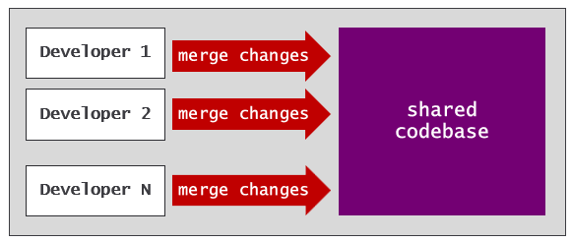
Continuous deployment (CD) is the practice of automating the deployment of code. Deployment is often preceded by some type of manual approval process in which one or more approvers must sign off on a release. Once a release has been approved, a continuous deployment process is automatically triggered to deploy these changes to a target environment.
With continuous deployment, you can build automated processes to route the lifecycle of application code through a sequence of environments. Promoting code changes through environments enables enhanced testing and for manual approval processes that ensure only high quality code reaches production. The release process in a CI/CD lifecycle is often built to promote changes through a standard set of environments such as dev, test and prod.
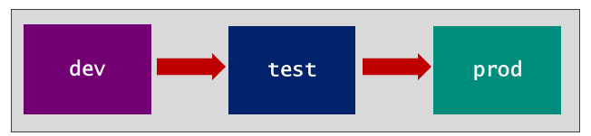

Fabric solutions
The way that you provide value to users on the Fabric platform is by building Fabric solutions. You build a Fabric solution by creating a composition of workspace items such as variable libraries, lakehouses, notebooks, pipelines, semantic models and reports. The Fabric platform currently offers 35 distinct workspace items types to chose from when designing a solution and that number is continually growing.
One important decision you must make when designing a Fabric solution is how many workspaces it requires to run. In many scenarios, a Fabric solution can be designed to run inside a single workspace. The following screenshot shows a simple example of a Fabric solution with five workspace items designed to run within a single workspace.
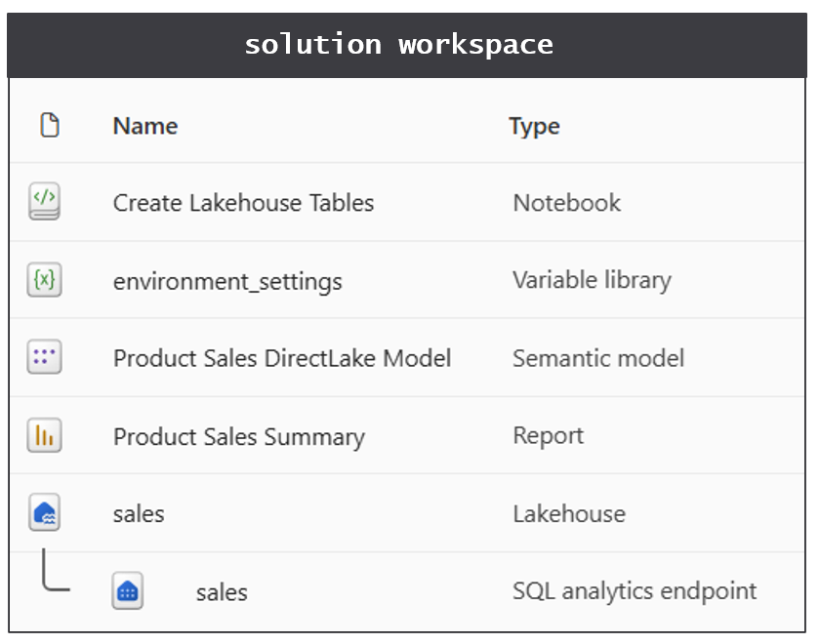
When building a Fabric solution with a large number of items, you can partition items using workspace folders. Workspace folders can assist with organizing items by role or by type. The use of workspace folders also helps to declutter the top-level folder which is the default view for business users.
There are scenarios where it's either impractical or impossible to deploy all the items for a Fabric solution to a single workspace. For example, Fabric imposes a limitation of 1000 items per workspace. If you build a Fabric solution with more than 1000 items, your must design the solution to span two or more workspaces. There can also be design factors or requirements with respect to security, least privilege and item ownership which can lead you to designing a Fabric solution with multiple workspaces.
Let's look at an example of a Fabric solution design which requires multiple workspaces. Imagine you are designing a Fabric solution with a medallion architecture and you're given the security requirement to prevent business form accessing staging data in the bronze lakehouse and the silver lakehouse. Keep in mind that workspace folders inside a single workspace cannot be used to configure security. When you configure access for users by adding a workspace role assignment, the users then can access anything inside. The best way to enforce the security requirement is to design the Fabric solution with a staging workspace and a presentation workspace.
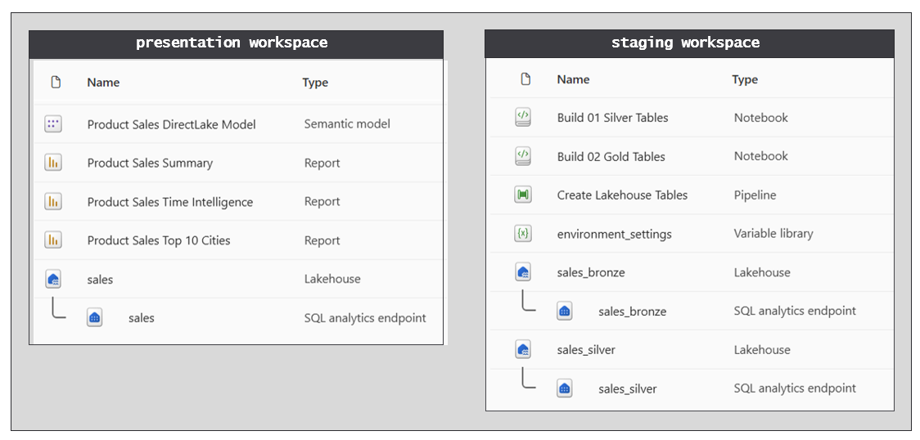
The staging workspace is designed to include all the items used to run ETL jobs and to store staging data. The presentation workspace is designed with the items which are intended for access by business users. After deploying this Fabric solution, you can configure access to each workspace independently. Now you can add a workspace role assignment to the presentation workspace for business user who need access reports, the semantic model and the gold lakehouse without providing access to anything in the staging workspace.

Fabric CI/CD projects
Imagine a scenario in which you have prototyped a Fabric solution using the platform's analytics and AI capabilities. You then shared the solutions with a few peers for review and you received positive feedback. After that, you were given the opportunity to present your Fabric solution to the leadership team. The leadership team loved it. In fact, they were so impressed that decided to 'productionize' your Fabric solution so it can be rolled out to a large audience of business users. This is the moment that a Fabric CI/CD project begins.
A Fabric CI/CD project involves applying the concepts of CI/CD to a Fabric solution. While the term Application Lifecycle Management (ALM) is widely used, it’s probably better to think about Fabric CI/CD as Solution Lifecycle Management (SLM). For example, you need to stand up multiple environments and get an instance of the Fabric solution running in each one. You also need to build the CI/CD processes to propagate solution updates from one environment to the next.
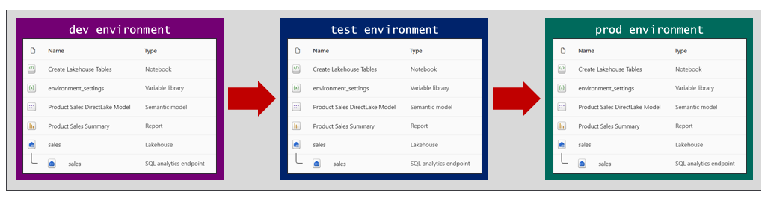
One essential aspect of planning a Fabric CI/CD project involves defining the requirements for the project's environments. The way to create an environment is by assembling a set of resources so you have a place to deploy and run the Fabric solution. At a minimum, an environment for Fabric solutions requires a workspace which is assigned to a Fabric capacity. In a project where the Fabric solution requires two workspaces, then you will need two workspaces per environment.
Another important considerations during the planning phase is whether each environment requires it own separate capacity. While you can assign workspaces from all environments to a single shared capacity, it's considered a best practice to isolate environments by creating a separate Fabric capacity for each one as shown in the following diagram.
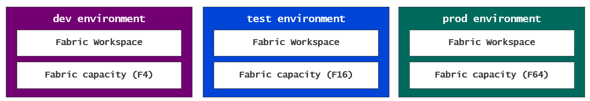
The Fabric CI/CD project examples in in this guidance use three environments named dev, test and prod. However, the environments you plan in your project can use other popular environment names such as qa, uat or ppe.
When planning the environments for a Fabric CI/CD project, you might decide to include other types of Azure resources as well. For example, you can design a Fabric solution to access data files from an Azure storage account. In this type of scenario, it makes sense to plan on creating a separate Azure storage account for each environment.
Remember that a primary motivation for environments is the ability to run a Fabric solution using different datasources for development, testing and production. During the environment planning phase you should map out all URLs and paths used to connect to external datasources. This guidance will explain best practices for implementing a parameterization strategy so that Fabric items in each environment connect to their environment-specific datasources.

Fabric CI/CD Capabilities
The Fabric platform provides the following capabilities to assist with building CI/CD processes.
- GIT Integration
- Branched workspaces
- Variable libraries
- Workspace Item Types
- Item Definitions
- Deployment Pipelines
This section will drill into each of these Fabric CI/CD capabilities along with a few other related topics. The goal is for you to build your understanding of how these pieces fit together before you move ahead to learn about Fabric automation and workflow development.

GIT Synchronization
The Fabric CI/CD infrastructure starts with its support for GIT integration. Imagine you’re on a team building a data analytics solution based on a Fabric workspace that includes a lakehouse, notebook, semantic model and report. Fabric makes it possible to maintain the source code for all four workspace items as a single source of truth in a GIT repository. Any updates made to workspace items can be versioned, tracked and compared to other versions.
Fabric's list of supported GIT providers includes Azure DevOps, GitHub and GitHub Enterprise. Microsoft is currently planning to add other popular GIT providers in the future. You can find the most up-to-date information about Fabric's support for GIT providers and their limitations by reading Supported Git providers.
Fabric’s support for GIT integration is enabled at workspace scope. More specifically, you enable GIT integration by connecting a workspace to a branch in a GIT repository. There are two steps required to connect a workspace to a branch in GIT. The first step is to create a Fabric connection to the target GIT repository. The second step is to configure a workspace-level setting which connects the workspace to a specific branch inside the GIT repository.
Fabric provides the Azure DevOps - Source control connector for connecting to Azure Dev Ops repositories. When creating a connection using Azure DevOps - Source control connector, you must configure connection credentials using an Entra Id identity which can be either a user principal or a service principal. Fabric provides the GitHub - Source control connector for connecting to repositories in GitHub and GitHub Enterprise. When creating a connection using GitHub - Source control connector, you must you must configure the connection credentials using a personal access token (PAT).
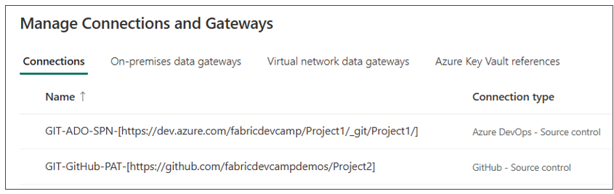
An essential aspect of Fabric GIT integration is its ability to dynamically generate item definitions from workspace items. When you connect a workspace to a branch in a GIT repository, Fabric runs a Commit to GIT operation which generates an item definition for each item and persists the item definition to the target GIT branch as a folder containing item definition files.
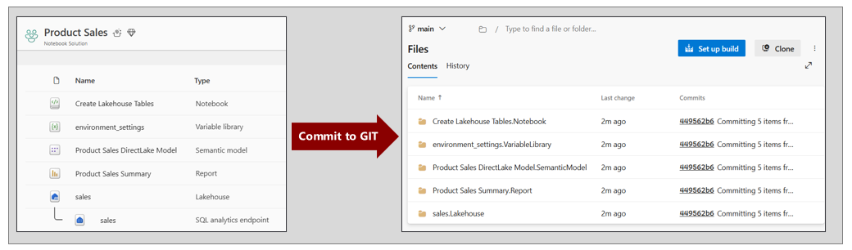
Fabric uses a naming convention for item definition folders which includes the item display name, a period and the item type in the format of [Item Display Name].[Item Type]. You can see from the previous screenshot that GIT synchronization creates folders using this naming convention for folder names such as sales.Lakehouse and Product Sales Summary.Report.
Once a workspace is connected to and synchronized with a GIT branch, the Fabric workspace List view displays a GIT status column that displays Synced to indicate all workspace items are in sync with the underlying item definitions stored in GIT.
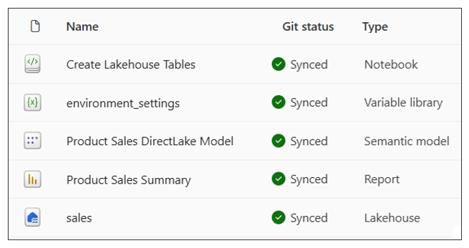
Fabric GIT integration also makes it possible to synchronize changes in the other direction. Think about a scenario in which all the items in a workspace are synchronized with a GIT branch. After that, new changes to an item definition are merged into the branch from another branch. You can run an Update from GIT operation to synchronize changes from item definitions in GIT to the items in the workspace.
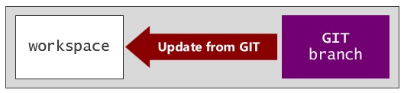
When you run an Update from GIT operation, Fabric checks to see whether a target items already exists for each item definition by checking for a match with the item display name and type. In the case where Fabric finds a matching item, it update the existing item to ensure it is kept in sync with the item definition. But what happens when Fabric cannot find an existing item to match an item definition in GIT? The answer is that Fabric uses the item definition to create a new item.
Consider a scenario in which you connect a GIT branch containing item definitions to an empty workspace and run an Update from GIT operation. Fabric creates a new item from each item definition in GIT. This leads to an important observation about GIT integration in Fabric. If you have a GIT branch which contains the item definitions for Fabric solution, you can use that GIT branch to deploy the solution to a target workspace.

GIT folder settings
When you use the Fabric UI to configure a connection between a workspace and a GIT branch, you are given the option to add a Git folder settings. If you leave the Git folder setting with its blank default value, Fabric GIT synchronization will create the item definition folders in the root folder of the target GIT branch. By adding a GIT folder settings, you can configure GIT synchronization to write its output to a child folder in the GIT branch instead of the root folder.
There are two important scenarios in which it's important to configure a Git folder setting. The first scenario involves any Fabric CI/CD project which requires adding workflow files such as YAML files and Python files into the same GIT repository. By configuring a Git folder setting, you can avoid the confusion mixing the item definitions files for workspace items together with other project files. The following screenshot shows the effect of configuring the Git folder setting with a value of /workspace.
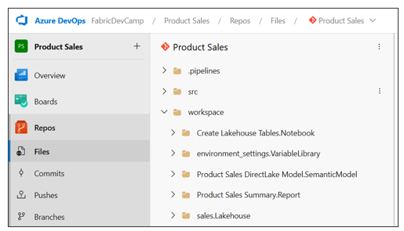
The Git - Connect API provides the directoryName parameter which you can use to configure the Git folder setting.
The second scenario where it's important to configure the Git folder setting involves a Fabric solution spread across multiple workspaces. Let's revisit the Fabric solution introduced earlier with a medallion architecture. The solution was designed with two workspaces to separate ETL logic from presentation. There is a staging workspace which contains notebooks and lakehouses for staging bronze and silver layer data and a presentation workspace containing the gold layer lakehouse, a semantic model and a report.
While it is possible to connect each workspace to its own separate GIT repository, that is a bad idea. Instead, you need an approach that results in creating a single source of truth in GIT for the Fabric solution as a whole. This remains true even when the solution spans multiple workspaces. The best practice is to synchronize both workspaces in a single GIT branch in the same repository. This is possible as long as you use a different Git folder setting for each workspace.
As an example, you can connect the staging workspace to the GIT branch with a Git folder setting of /workspace/staging. You can connect the presentation workspace to the same GIT branch with a Git folder setting of /workspace/presentation. This design is essential for Fabric solutions with multiple workspaces because it effectively creates a single source of truth in GIT for the solution as a whole.
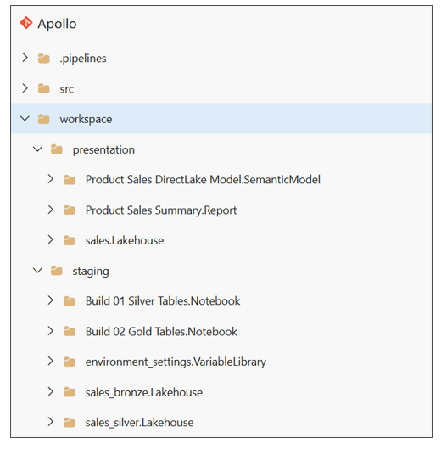

Feature Workspaces
The use of features branches has become widely adopted in software development. A development process based on feature branches allows developers to work and commit changes in isolation. You can also configure a feature branch with workflows that are triggered whenever changes are committed. These workflows can automate running tests with linters, validation checks and security scans as part of the continuous integration process to improve the quality of code that reaches production.
After committing changes to a feature branch, the next step is to create a pull request to merge those changes to the shared branch. You can think of a pull request as a proposal that allows collaborators and release managers to review a set of changes. GIT providers such as Azure DevOps and GitHub make it possible to configure pull requests with manual approval processes that are as simple or as complex as required for a given scenario. When the approval process for a pull request completes, the changes are automatically merged to the shared branch which is known as the integration branch.
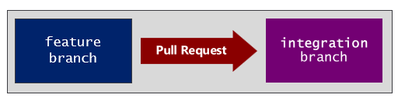
The integration branch is an essential concept in continuous integration. The integration branch is the shared branch where the changes of all developers are merged together. It's called the integration branch because its contents represent the single source of truth that is always ready for deployment to test environments and production environments. Remember that the integration branch is a concept not a name. An integration branch typically has a name such as main or dev.
Creating and managing pull requests
- Create pull requests in Azure Dev Ops
- Creating a pull request in GitHub
For developers migrating to Fabric with experience in traditional CI/CD, some aspects of Fabric CI/CD will be familiar while other aspects will not. For example, these developers may already be familiar with creating feature branches and pull requests. However, things are different in Fabric CI/CD because each feature branch must be matched up and connected to a feature workspace.
Let's walk through the high-level steps to build a development process for Fabric CI/CD project using feature workspaces. The first step is to create a single source of truth in GIT. For this you need to create a GIT repository and you need to determine which branch will serve as the integration. After that, you can create the single source of truth by creating a set of item definitions in the integration branch.
While there are several approaches you can use to create the initial set of item definitions in the integration branch, a common approach involves getting a version of the Fabric solution up and running in a dev workspace. This makes it possible to connect the dev workspace to the integration branch and run a Commit to GIT operation. The Commit to GIT operation creates an item definition in the integration branch for each item in the dev workspace.
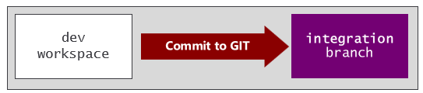
When you run a Commit to GIT operation to create item definitions in the integration branch, this should be considered a one-time operation. Once you have created the item definitions which represent the single source of truth, you should refrain from directly updating items or running Commit to GIT operation in the dev workspace. Instead, future changes should be merged from feature branches to the integration branch. This disciple can be enforced by configuration the integration branch in GIT with a branch policy that only allows updates through pull requests.
Once the integration branch has been configured as a single source of truth, you can begin to create feature workspaces. This process involves two steps. First, you create a new feature branch based on the integration branch. After that, you create a new workspace and connect it to the feature branch and run an Update from GIT operation. This flow will automatically populate the feature workspace with a matching set of workspace items.
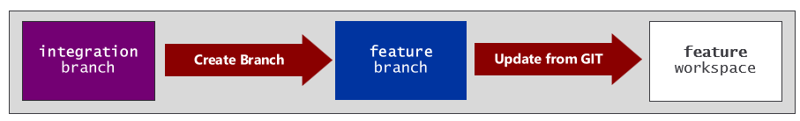
When you initialize a feature workspace with an Update from GIT operation, you're often required to complete additional configuration steps before it's ready for development. This topic will be revisited shortly in the discussion of automation.
Once you standardize on a process for creating feature workspaces, you can begin to build what's required for continuous integration. The following diagram shows a development process built using feature branches and feature workspaces. This is an approach which can scale to accommodate a larger number of developers or development teams.
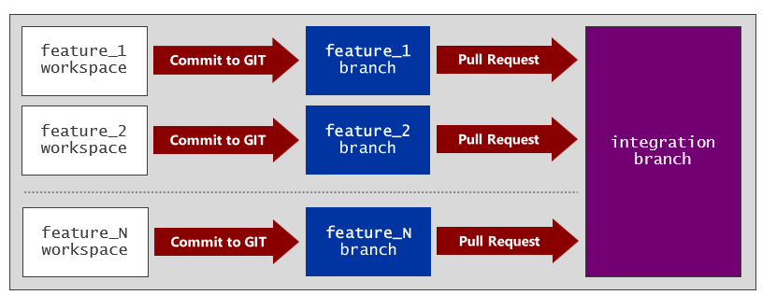
Keep in mind that feature branches should be short-lived. You don't want a feature branch hanging around too long because that increases the risk of merge conflicts with the integration branch. It's a common practice to delete a feature branch as soon as a pull request completes and merges its changes to the integration branch.
When it comes to managing the lifecycle of feature workspaces, you have two options. The first option is to manage the feature workspace lifecycle to coincide with feature branches. When using this approach, you delete the feature workspace and the feature branch at the same time after the pull request completes and its changes have been merged.
A second option is recycle feature workspaces by reusing them across pull requests. For example, you can create a feature workspace for a specific developer or development team working in a particular area. As an example, you can create a dedicated feature workspace for the Spark team writing ETL logic in notebooks to build lakehouses tables. You can create a second feature workspace for the data modeling team working with semantic models. You can create a third feature workspace for the analytics teams who will be continually updating reports.

Branched Workspaces
Fabric offers branched workspaces to assist with creating and managing feature workspaces. Fabric support for branched workspaces offers a streamlined user experience which simplifies creating feature workspaces and switching between feature branches. Building out the development process using branched workspaces enhances productivity because Fabric is able to create new GIT branches and managing GIT connections behind the scenes.
Consider a scenario in which the dev workspace is connected to an integration branch named main in a GIT repository. If you navigate in the dev workspace to the Branches panel of the Source control pane, you can find a set of branching commands which include Branch out to workspace.
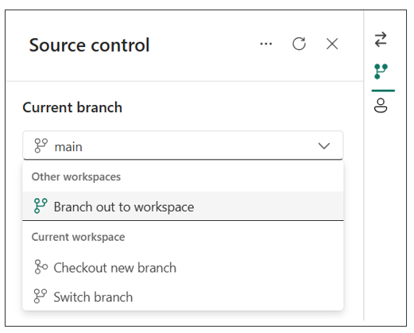
When you run the Branch out to workspace command, Fabric prompts you with a dialog to enter a new branch name. The Branch out to workspace dialog also allows you to choose between creating a new feature workspace or connecting to an existing feature workspace.
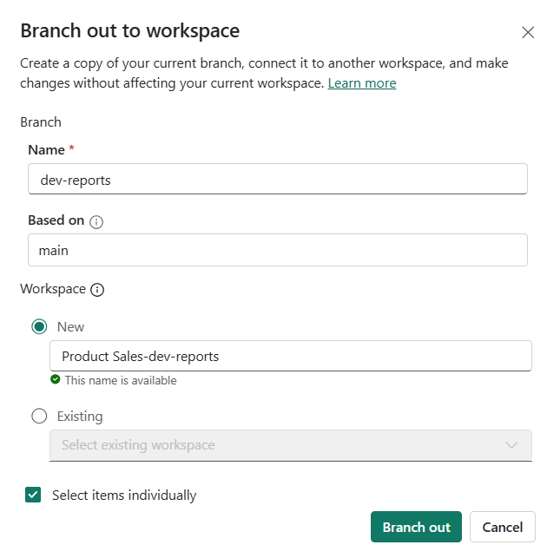
The Branch out to workspace dialog provides an option to Select items individually to enable a capability known as selective branching. If you select this option and click the Branch out button, you will be prompted with another dialog which allows you to select which items to include in the branch out process.
Selective branching is particularly useful in scenarios which include workspaces containing a large number of items. It can take a long time to run a full branch out process when the dev workspace that contains 100s of items. Selective branching allows you to complete the branch out process much faster in a case where you only need to work on a small subset of items. After the initial branch out, you can also incrementally add other items to the branched workspace as needed.
When you branch out to a feature workspace, Fabric creates a relationship between the branched workspace and the shared dev workspace connected to the integration branch. This makes it easier to visualize the high-level development process for a Fabric CI/CD project. If you navigate the Related Branches view in the Source control pane, you can see the top navigation node in the hierarchy displays the integration branch named main and the name of the shared dev workspace. Each child node displays the name of each feature workspace along with its underlying GIT branch name.
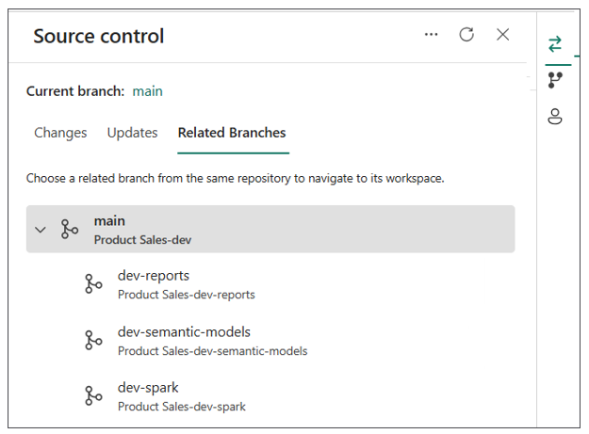
Within each branched workspace, Fabric also provides a workspace breadcrumb menu that allows you to visualize that this feature workspace is related to the shared dev workspace connected to the integration branch.
An important consideration when working with the Branch out to workspace command involves the permissions required in the GIT repository and in Fabric. To branch out to a new workspace, you must have permissions to create new branches in the GIT repository. You also need permissions in Fabric to create new workspaces and to assign workspaces to a Fabric capacity.
More info on branching workspaces in Fabric
- Development process using branched workspace
- Required Git permissions for popular actions
- Required Fabric permissions for popular actions
Microsoft is currently working to enhance branched workspace capabilities to address issues that customers face with permissions. Fabric plans to introduce a new delegated model to enable self-service branch out operations for users that do not posses the permissions to create workspaces or assign a workspace to a Fabric capacity.
In addition to the Branch out to workspace command, there are several other commands in the Source control pane that used to manage branched workspaces and their connections to feature branches. The Switch branch command allows you to switch the connection for the current workspace from one branch to another in the same GIT repository. Before switching to another branch you must either commit or discard any uncommitted changes in the workspace. When switching to a different branch, Fabric runs an Update from GIT operation which can involve adding, updating and/or deleting workspace items in the current workspace.
The Check out new branch command runs a set of operations that can assist with resolving merge conflicts between a feature branch and the integration branch. This command allows the user to switch from the current branch to a new branch without having to discard any changes in the current branch. This command is used to resolve merge conflict scenarios.
More info on branching workspaces in Fabric
- Development process using branched workspace
- Required Git permissions for popular actions
- Required Fabric permissions for popular actions

Variable Libraries
An essential aspect of the CI/CD lifecycle involves promoting changes through a sequence of environments. The canonical example is a Fabric solution lifecycle which moves changes through environments such as dev, test and prod. When you need to test and validate code for a project across multiple environments, it’s essential to find an effective parameterization strategy for environment-specific settings.
The Fabric platform provides the variable library to assist with parameterization. The variable library is a creatable type of workspace item in which you can define a set of variables. Other workspace items such as notebooks, pipelines, copy jobs and dataflows can be defined to read variable values from a variable library. This makes it possible to avoid hardcoding configuration settings that change across environments.
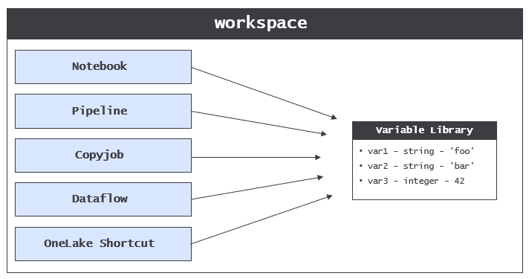
Consider the classic scenario in which you need to build a release process that moves workspace item updates through a sequence of workspaces representing environments such as dev, test and prod. The problem is that items in different workspaces must be configured with different settings to connect to a different database or to some other type of datasource. To solve this problem, items in each workspace requires access to their own unique connection settings.
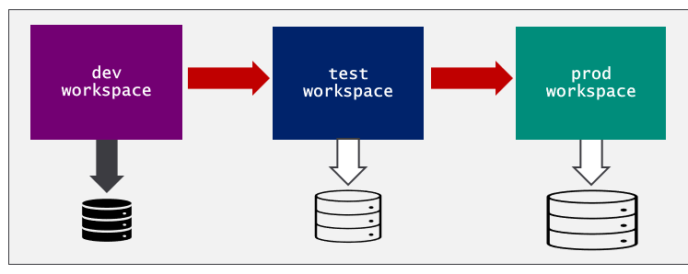
The variable library was designed to solve the problem of parameterizing these types of settings across workspaces. A variable library allows you to avoid hardcoding the configuration settings required to connect to a database. Consider a scenario in which you must write Python code in a Fabric notebook to connect to a SQL database. The thing you want to avoid is hardcoding these configuration settings into your code as literal strings.
database_server = 'devcamp.database.windows.net'
database_name = 'ProductSalesDev'
The obvious problem is that these hardcoded settings are specific to a single environment. As an alternative, you can leverage a variable library to enable support for parameterization. You start by creating a new variable library with a display name such as environment_settings. Next, you can add two string variables named database_server and database_name.
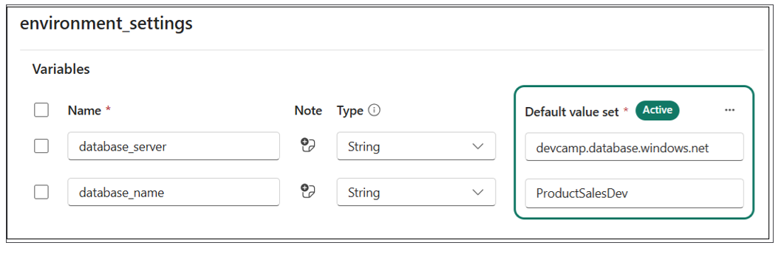
Once you have created the variable library with the two variables, you can remove the hardcoded configuration values from the notebook and replace them with code to read the variable values at run time.
database_server = notebookutils.variableLibrary.get("$(/**/environment_settings/database_server)")
database_name = notebookutils.variableLibrary.get("$(/**/environment_settings/database_server)")
You have learned that a variable library allows you to add variables. That's probably not too surprising. However, variable libraries have another important dimension used to provide parameterization support across workspaces. More specifically, Fabric allows you to extend a variable library using value sets.
Let's take a step back to build your understanding of why value sets are important. You've learned that a variable library is a collection of variables where each variable is defined with a name, a type and a default value.
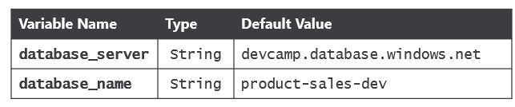
The purpose of a value set is to provide an alternate set of values for each of the variables in the variable library. Consider an example of a variable library in which the default values have been configured for the dev environment. You can extend the variable library by adding a value set for the test workspace and a second value set for the prod workspace.
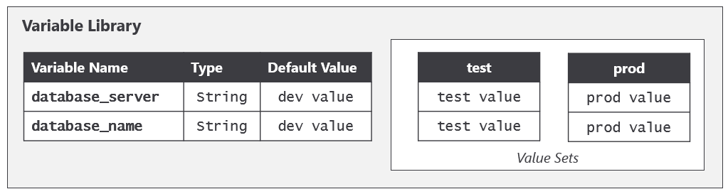
The item definition for a variable library includes variables and values sets. However the item definition does not contain anything to indicate which value set is active. That's because Fabric maintains a separate workspace-level setting that tracks which value set is active in the context of that workspace. That means three different workspaces could each contain a variable library with an identical item definition, yet each workspace can be configured to use a different value set.
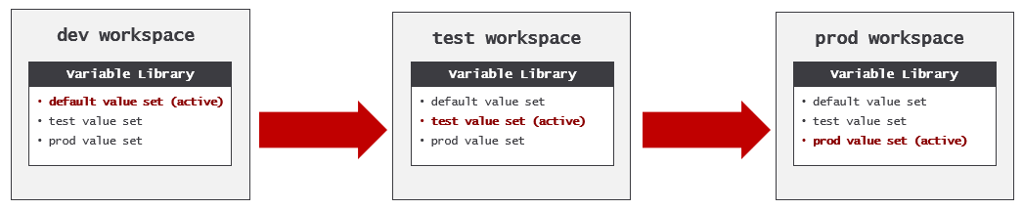
You can create variables in a variable library based on standard types including String, Number, Integer, DateTime and Guid. Variable libraries additionally support two important reference variable types which are Connection reference and Item reference. Using these reference variable types makes it easier to edit variable values through the Fabric UI. When you edit the value of a reference type variable, Fabric presents with an item picker showing a list of candidate items from which to choose.
Connection reference variables are commonly used to parameterize connections for items involved with ETL such as pipelines and shortcuts in a lakehouse. It's a best practice to design items which connect to external datasources using a variable library which includes a connection reference variable and other variables which parameterize datasource paths. Using a connection reference variable is considered a best practice because it removes anything from the item definition that is environment specific.
Item reference variables are useful for managing dependencies between items in the same solution. This is especially true when you need to deal with an item dependency that spans across workspace boundaries. Let's revisit the scenario with the multi-workspace solution introduced earlier. There is a notebook in the staging workspace that needs to write its output to a lakehouse in the presentation workspace with gold layer tables. You can use an item reference variable to parameterize the target lakehouse. This, in turn, provides the ability to remove any code from the notebook which is environment specific because the notebook can use the item refence to determine where to write its output.

Workspace Item Types
Every Fabric solution is designed as a composition of workspace items and each item is based on a workspace item type which defines its capabilities and the user experience it provides in the Fabric service.
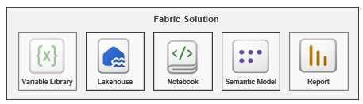
The core abstraction of the workspace item type in Fabric is what allows artifacts from different Fabric workloads to behave in a similar and consistent manner. For example, each workspace item type provides the GIT synchronization capability to generate an item definition for a workspace item and to store that item definition in GIT. Likewise, each workspace item type provides the complimentary behavior to respond to Update from GIT operation by either creating or updating an item using an item definition in GIT.
It is important to understand that Fabric is an evolving platform. The behavior of workspace item types is updated on a regular basis. Moreover, Fabric is continually adding new workspace item types to the platform. As a result, some workspace item types are more mature than others with respect to their CI/CD capabilities.
There are four primary CI/CD capabilities that are supported by some but not all workspace item types.
- Support for reading variables from a variable library
- Support with Fabric REST APIs to create and update items using item definitions
- Support for calling Fabric APIs using a service principal identity
- Support for auto-binding workspace item dependencies
Whenever possible, you should use variable libraries to manage parameterization across environments. However, not all workspace item types support variable libraries. So, what should you do when you are building a Fabric solution and you encounter a workspace item type that does not support variable libraries? To achieve the same goal with respect to parameterization, you might be required to make direct edits to an item definition either in GIT or through a Fabric REST API call.
There can also be differences between workspace items types in their support for the Fabric REST APIs. While some workspace item types support creating and updating workspace items using item definitions, others do not. You also might encounter workspace item types do not support calling the Fabric REST APIs as a service principal. This is especially true as workspace item types are initially released in public preview.

Auto-binding Support
The majority of Fabric workspace item types are able to self-manage their relations to other items in the same workspace. More specifically, some workspace item types can auto-bind to the other items on which they depend. This auto-binding behavior occurs as part of the GIT synchronization process. Workspace item types that do not support auto-bind behavior require your attention because you might be required to run a script after an Update from GIT operation completes to correctly rebind item dependencies.
Take an example of a Fabric solution composed of a lakehouse, a notebook and a pipeline. Assume that the notebook has a dependency on the lakehouse and that the pipeline has a dependency on both the lakehouse and the notebook. After you have built out the solution in the dev workspace, there are three established dependencies between these workspace items.
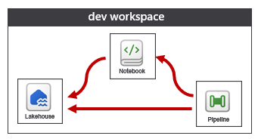
Now think about what happens when you use Fabric GIT synchronization to replicate these three workspace items from the dev workspace to a feature workspace. The outcome you want to avoid is for workspace items created in the feature workspace to retain their dependencies pointing back to an item in the dev workspace. Instead, the desired outcome is for each workspace item to properly resolve its dependencies to its related items in the same workspace. You can see from the following diagram that the notebook and pipeline in the feature workspace were both able to self-manage their relations.
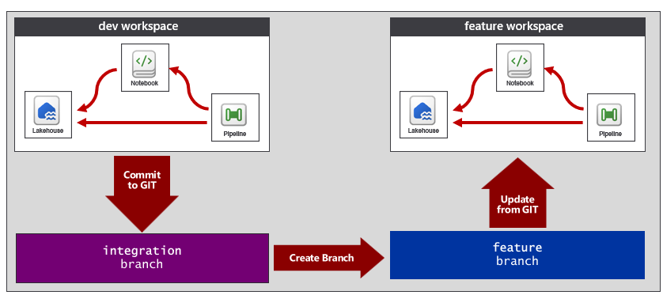
Fabric notebooks did not support auto-binding until Microsoft updated the Notebook item type with auto-binding support in March of 2026. It is also noteworthy that notebooks do not support auto-binding by default. Instead, you must extend a notebook's item definition with a notebook-settings.json file as discussed the following section on item definitions.
Also, keep in mind that not all workspace item types support auto-binding. If you're building a Fabric solution with an item type that lacks support for auto-binding, you might be required to write a script for a post-sync job to reestablish relations.

Item Definitions
Item definitions represent an essential component type in the Fabric platform's support for CI/CD. At its core, an item definition is a named folder containing a set of files which contain settings and metadata to represent an item of a specific workspace item type. While the files in an item definition vary significantly from one workspace item type of another, the idea that every type of workspace item can be serialized into a folder in GIT provides the foundation of the Fabric CI/CD infrastructure.
Every item definition requires a file named .platform which is known as the platform file. The platform file contains metadata such as the item type and display name. The platform file also contains a logicalId value which is used by Fabric internally to track logical instances of workspace items as they are propagated across GIT branches and workspaces.
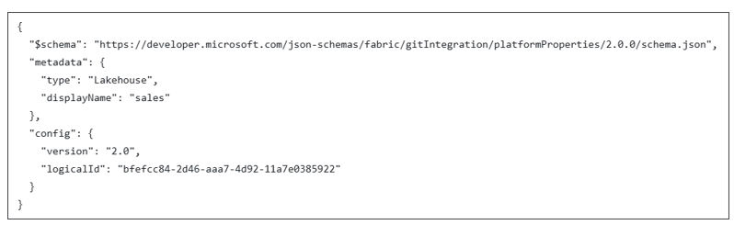
In addition to the platform file, each workspace item type defines its own unique schema for the files required and/or allowed in an item definition. As an example, the item definition for a lakehouse contains files such as alm.settings.json, lakehouse.metadata.json and shortcuts.metadata.json.
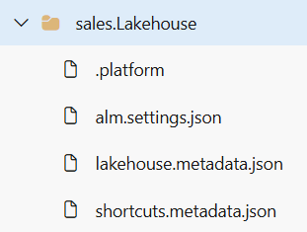
The minimal item definition for a notebook just requires one file named notebook-contents.py in addition to the platform file.
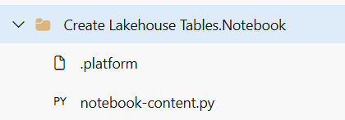
Remember that notebooks do not support auto-binding behavior by default. However, you can extend the item definition for a notebook to support auto-binding by adding a notebook-settings.json file with content as shown in the following screenshot.
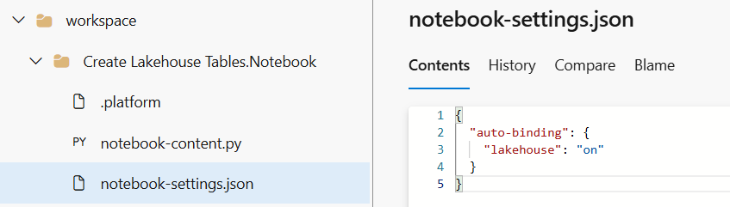
Note that Fabric supports working with item definitions for notebooks using either the .py format or the .ipynb format.
While some item definitions contain a small number of files, that is not always the case. As an example, the item definition for a semantic model can include dozens or even hundreds of TMDL files which are structured across several folders
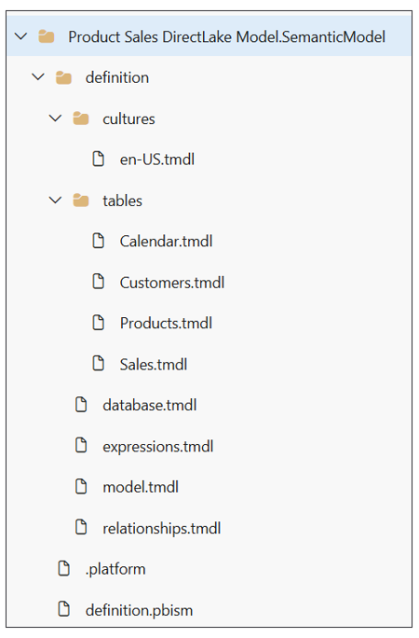
While an item definition with a large number of files adds complexity, it also allow for collaboration in a much more granular fashion. Consider the benefit of splitting out each table into its own file in the item definition for a semantic model. This file structure allows one developer to work on the measures in the Sales table while another developer is making changes to the Calendar table. This extra granularity is essential when multiple developers are working on a large semantic model at the same time.
In this section, you have seen examples of item definitions for lakehouses, notebooks and semantic models. However, you will be working with workspace item types beyond these three. In general, you should gain a basic understanding of item definition files for each of the workspace item types you work with in a Fabric CI/CD project. An easy way to get started is to walk through item definition files in GIT which have been created using GIT synchronization.
Fabric Item Definitions
- Item management overview
- Item definition overview
- GIT Repository with public item definition schemas

The Role of the logicalId
Using Fabric GIT integration, you are able to replicate a set of workspace items from one workspace to another. As an example, imagine you have created a lakehouse named sales and you have used GIT synchronization to replicated the lakehouse across three different workspaces. All three lakehouse instances share the same type and display name. However, each lakehouse instance is assigned a unique id.
In order to support auto-binding behavior, Fabric needs a way to track that these three lakehouse instances are all associated a single logical item. This is where the logicalId comes in. While each lakehouse instance has it own unique id, all three lakehouses share the same logicalid.
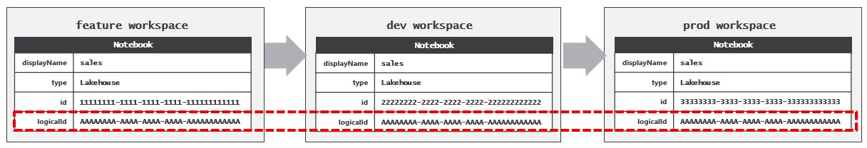
The role of the logicalId is important because it allows Fabric to avoid persisting workspace-specific item ids into GIT. This level of indirection is what makes it possible for Fabric to support auto-binding. As an example, examine the following code snippet from the item definition for a pipeline that has a dependency on a lakehouse in the same workspace.
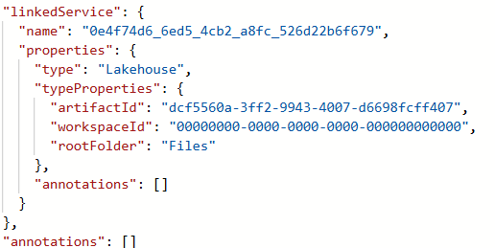
You should notice that the workspaceId does not have value that references an actual workspace id. Instead, the workspaceId has an empty GUID value of 00000000-0000-0000-0000-000000000000 which indicates that the artifactId has a value that references the logicalId of the lakehouse instead of a workspace-specific item id. When you run an Update from GIT operation which creates the lakehouse and pipeline in a new workspace, Fabric is able to use the logicalId to lookup the workspace-specific lakehouse id which is then used to bind the pipeline to the lakehouse in order to reestablish the relation.
It's unlikely that you will ever need to work directly with the logicalId. In general, you can think of the logicalId as an internal property used by Fabric behind the scenes. Furthermore, You should never modify a logicalId value as this is an unsupported action that can lead to unpredictable behavior.

Deployment Pipelines
The Fabric platform provides Deployment Pipelines as a continuous deployment mechanism to help manage the lifecycle of workspace items. The key concept behind Deployment Pipelines is that changes to workspace items can be deployed through a set of stages where each stage is assigned to a Fabric workspace associated with an environment. The following screenshot shows the user interface of a Deployment Pipeline which makes it possible to deploy item-level changes across workspaces.
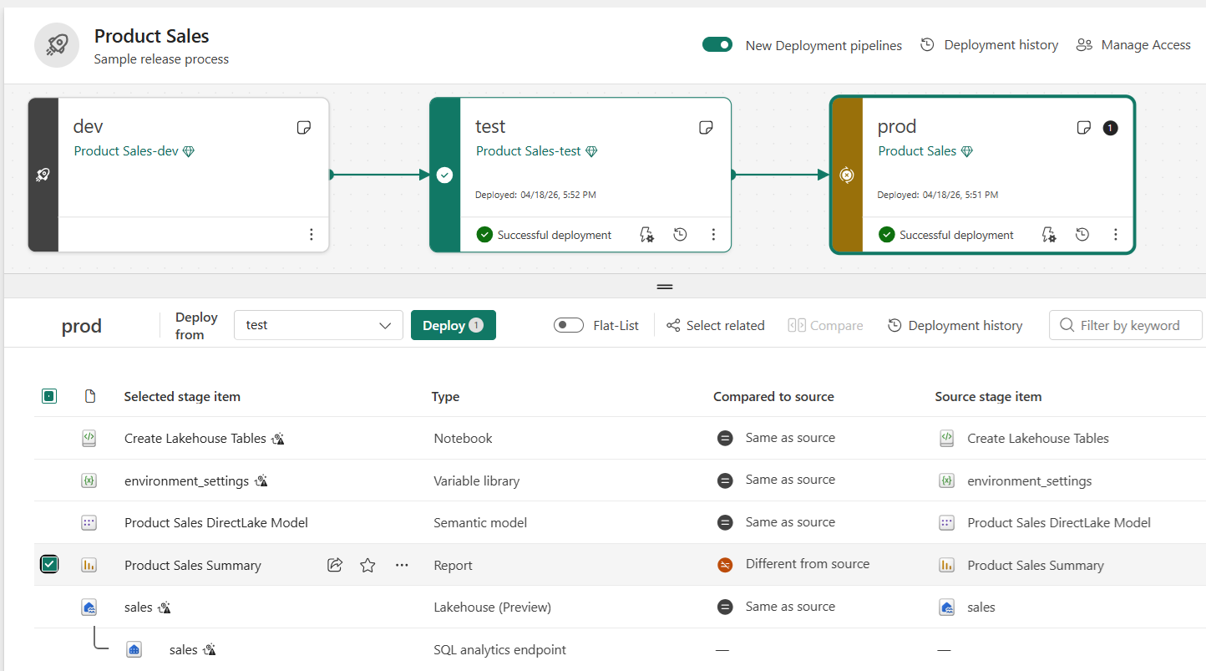
Deployment Pipelines are designed to enhance productivity by hiding low-level details associated with propagating changes through a sequence of workspaces. Deployment Pipelines are similar to GIT synchronization in that they automatically rebind item relationships when deploying a Fabric solution with item dependencies between lakehouses, notebooks and pipelines.
Deployment Pipelines were originally introduced in the Power BI service several years before Microsoft first released Fabric. In their initial release, deployment pipelines offered deployment rules as a mechanism used to support parameterization. For example, you can configure a semantic model with a deployment rule to update its datasource location so the semantic model in each of the three workspaces connects to its own environment-specific database.
Deployment Pipelines in Fabric continue to support deployment rules. However, deployment rules should not be your first choice when it comes to parameterization. Instead, you should prefer using variable libraries to solve parameterization problems. The key point is that variable libraries are strategic in the Fabric roadmap while deployment rules are not.
As of June 2026, semantic models do not yet support variable libraries. Therefore, configuring datasource location in a Deployment Pipeline using deployment rules is your best option until Microsoft releases variable library support with semantic models which is expected in the second half of 2026.
Deployment Pipelines are designed to assist with continuous deployment in building a release process. Keep in mind that the release process only covers the second half of full CI/CD lifecycle. The use of Deployment Pipelines should be combined together with Fabric GIT integration to fully implement a complete end-to-end solution. This topic will be revisited in the upcoming section on building a release pipeline.

Automation in Fabric CI/CD
Rolling out a Fabric project with end-to-end CI/CD support requires a significant number of steps. Your ability to automate the setup process is essential. The alternative approach, known as ClickOps, involves completing setup tasks by hand using a browser. Relying on ClickOps is bad because it’s prone to human error causing unnecessary delays and the need to troubleshoot configuration errors. This is especially true when considering how to create a fast and reliable plan for disaster recovery.
The Fabric platform provides public APIs which make it possible to automate setup and CI/CD processes for a Fabric project. The primary API used to create workspace, connections and workspace items is the Fabric REST APIs. While you can write code that calls the Fabric REST APIs directly, you also have the option to boost your productivity by leveraging developer tools and libraries which call the Fabric REST API on your behalf as shown in following diagram.
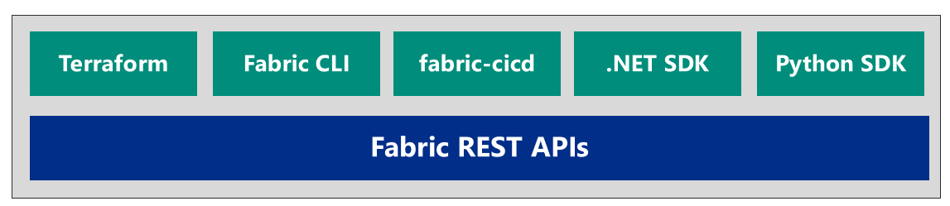
This section will begin by examining the most common scenarios which require you to write automation logic. For example, you will learn what needs to be automated during the project setup phase. You will also learn why and when you need to develop workflows which must be integrated into the development process as well as the release process.
Once you understand what needs to be automated, you will next learn your options for writing and versioning automation logic. You will learn about essential developer tools including Terraform and the Fabric CLI. The section will also introduce the fabric-cicd library and explain why it has been adopted as a best practice for building the release process for Fabric solutions. The sections concludes with a primer on Fabric REST APIs programming for developers that need the greatest level of control with Fabric automation.

Determining What Needs To Be Automated
The first part of your journey to roll out a Fabric CI/CD project is setting up the project's infrastructure. The infrastructure for a Fabric CI/CD project includes tenant-scoped items in Fabric such as workspaces, capacities, connections, gateways and deployment pipelines. You'll also need to create a GIT repository and configure GIT integration support between Fabric workspaces and GIT branches.
After a Fabric CI/CD project is up and running, there is often an ongoing need to create and configure feature workspaces. Consider the flow for creating a new feature workspace which involves creating a new feature branch from the integration branch and then running an Update from GIT operation against a new workspace.
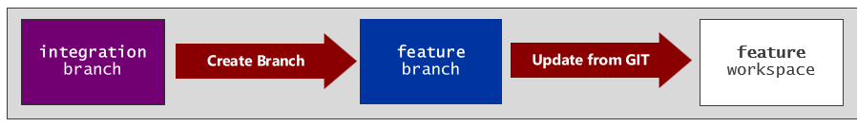
The problem is that the Update from GIT operation doesn't go far enough. For example, the Update from GIT operation will create a lakehouse, but it will not automatically populate the lakehouse with tables. The Update from GIT operation will create a semantic model, but it will not automatically create and bind a connection to the semantic model's datasource.
The key observation is additional automation is often required after a workspace has been initialized or updated with an Update from GIT operation. This provides a motivation for writing custom scripts to complete whatever tasks are required to prepare a feature workspace for development. As you begin developing these types of scripts, you should consider two different types of jobs.
- Post-deploy jobs run only once after an empty workspace is first initialized with an Update from GIT operation.
- Post-sync jobs run each time after an Update from GIT operation completes on a workspace.
You can think of a post-deploy job as a set of one-time tasks that are part of the workspace initialization process. An example of common tasks automated in a post-deploy job are setting the active value set for a variable library and running a notebook to populate a lakehouse with data. Another common task is creating and binding a connection for each semantic model. If your Fabric solution includes a semantic model built using import, you should also automate the process of running a refresh operation to ingest and store the imported data.
You should avoid adding ETL logic directly into the scripts that you write for post-deploy jobs. Instead, it's recommended that you factor out ETL logic and add it into workspace items designed for ETL purposes such as notebooks, pipelines, copy jobs, user-defined functions and dataflows. If you write the logic in a post-deploy script to discover a notebook by name and then run it, you can then update the ETL logic in the notebook without requiring any updates to the script. This is an important topic that will be visited in the section on data orchestration.
A post-sync job contains logic that must run every time after an Update from GIT operation completes. As an example, consider the scenario where a developers makes a series of changes to items in a feature workspace which are committed to GIT in the feature branch. After that, a pull request is created and approved to merge the changes into the integration branch.
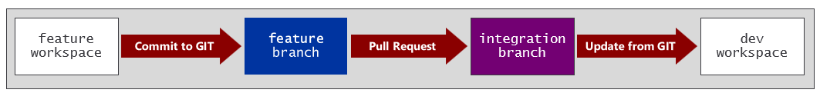
How do you synchronize the dev workspace with changes merged into the integration branch? You can start by developing a workflow that is triggered whenever changes are merged into the integration branch. This workflow should start by running an Update from GIT operation to sync changes from the integration branch to the dev workspace. However, some workspace items might require additional modification after the Update from GIT operation completes. This can be the case when you are working with workspace items that do not support auto-bind behavior. It can also be the case when you re working with items which do not yet support variable libraries yet require environment-specific settings.
There are several different ways to author automation logic. Regardless of Whether you use a tool or you call Microsoft APIs directly, you must consider the identity used to run your automation jobs. Every call to Fabric REST APIs executes under the identity of a specific Entra Id security principal. Fabric REST APIs support two types of identity which are user principals and service principals. It is a best practice to execute API calls as a service principal. This is especially true when code with workflow automation logic for CI/CD processes executes in a cloud-based platform such as Azure pipelines or GitHub Actions workflows.

Creating Project Infrastructure using Terraform
Terraform is an open-source tool built on the principles of infrastructure as code (IaC). IaC is based on the pattern of defining the infrastructure for a software project using configuration files as opposed to using manual processes or procedural programming logic. For many organizations managing cloud based deployments, the use of IaC has become a well-established best practice in DevOps and CI/CD.
Terraform offers the advantage of building a deployment process that is both versionable and repeatable. For example, you can version a Terraform configuration simply by adding its configuration files to a GIT repository just as you would version any of type of source files. A Terraform deployment process is also repeatable. That means you can run it again and again and it will produce the same outcome. A repeatable process provides consistency and the fastest path to disaster recovery.
From an architectural perspective, Terraform plays the role of an orchestrator which completes its work by calling APIs behind the scenes. But Terraform doesn't call these APIs directly. Instead, it delegates this work to Terraform providers which are plugin components designed to interact with a specific set of cloud-based APIs. One reason that Terraform has become so popular is due to its registry which contains 1000s of available providers allowing you to manage resources in platforms such as Azure, AWS, and Google cloud. Microsoft released the Fabric provider for Terraform in 2025 making it possible to set up the infrastructure for a Fabric CI/CD project using an IaC-based provisioning process.
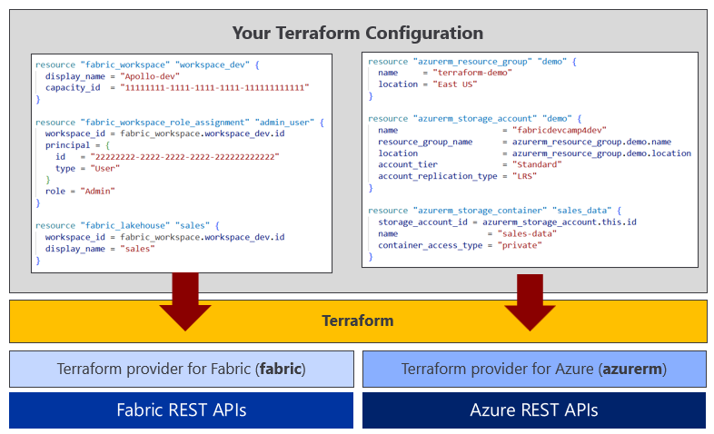
A Terraform configuration is defined using a set if files containing HashiCorp Configuration Language (HCL). Let's walk through a simple example of a Terraform configuration which uses a standard project file structure. The following screenshot shows simple Terraform configuration with five files. The variables.tf file is used to define a set of typed variables. The terraform.tfvars file is used to assign variable values in a scenario in which Terraform is running locally in a client tool such as Visual Studio Code.
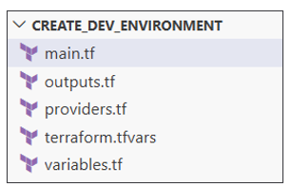
Note that the terraform.tfvars file often contains sensitive information such as a client secret to authenticate as a service principal. For this reason, it's common to add a .gitignore file so the terraform.tfvars is never uploaded into a GIT repository.
HCL is a superset of JSON which uses syntax based on blocks which contain arguments. The providers.tf file contains a terraform block with two arguments named required_version and required_providers. The required_version argument specifies the minimum version of Terraform and the required_providers argument contains a block for each provider with the source and version. This examples demonstrates loading the Fabric provider for Terraform. The providers.tf file also contains a provider block for the Fabric provider which authenticate as a service principal by using variable values to set the arguments tenant_id, client_id and client_secret.
terraform {
required_version = ">= 1.8, < 2.0"
required_providers {
fabric = {
source = "microsoft/fabric"
version = "1.8.0"
}
}
}

# SPN authentication for Fabric Provider
provider "fabric" {
tenant_id = var.tenant_id
client_id = var.client_id
client_secret = var.client_secret
}
Once a Terraform configuration contains what's required to initialize the provider, the next step is to run the terraform init command. Running terraform init downloads the executable code for the provider along with extra security configuration used to verify nobody has tampered with the downloaded provider code.
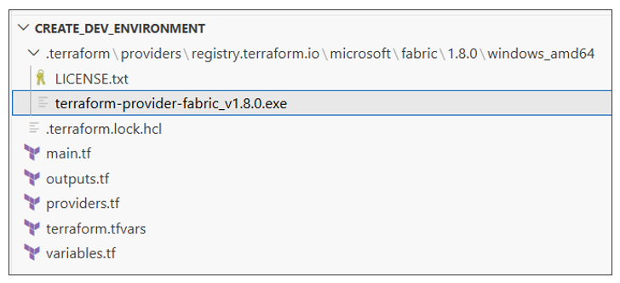
After initialing the Fabric provider, the next step is create resources by adding resource blocks to main.tf. Each resource block requires a provider-specific resource type and a local resource name. The Fabric provider offers the fabric_workspace resource type for creating workspaces and the fabric_workspace_role_assignment resource type for configuring access by adding workspace role assignments.
resource "fabric_workspace" "workspace_main" {
display_name = var.workspace_name
capacity_id = var.capacity_id
}

resource "fabric_workspace_role_assignment" "admin_group" {
workspace_id = fabric_workspace.workspace_main.id
principal = {
id = var.admin_group
type = "Group"
}
role = "Admin"
}

resource "fabric_workspace_role_assignment" "dev_group" {
workspace_id = fabric_workspace.workspace_main.id
principal = {
id = var.dev_group
type = "Group"
}
role = "Member"
}

When creating a fabric_workspace resource, you need to specify argument values for display_name and capacity_id. You should also take note that the fabric_workspace resource is assigned a local name of workspace_main. The local name is important because it makes it possible to create references using the syntax fabric_workspace.workspace_main.id.
Once you have created a Terraform configuration with a set of resources, you can run the terraform plan command to review a planned lists of the steps required to deploy the configuration. However, running the plan command doesn’t actually do anything. It just shows you the list of steps that need to be completed. When you're ready to deploy, you run the Terraform apply command to run the job that creates the resources needed to match your configuration.
When you first run the apply command to deploy a configuration, Terraform creates a state file named terraform.tfstate to track the property values for each resource as it's created or updated. The following screenshot shows an example of the state tracked for a fabric_workspace resource which include property values for id, display_name, capacity_id and capacity_region. There is even state used to track the OneLake endpoints that Fabric creates for a workspace.
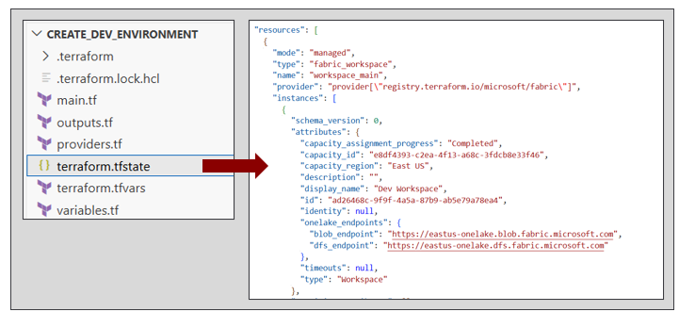
By default, Terraform creates the terraform.tfstate file locally in the root folder of the current configuration. Running Terraform with a local state file keeps things simple when you're first learning to use Terraform and when you are developing and testing configurations. In production, things are quite different. That's because it is critical to initialize a configuration to manage the state file in cloud storage such as an Azure storage account. Also keep in mind that the state file often contains sensitive data such as authentication credentials. Therefore, it is a best practice to limit access to the state file and to encrypt its contents.
This sample configuration also contain an output.tf file with output blocks created to capture property values for resources that have been created by the configuration. Here is an example of two output blocks used to provide values for the workspace id and DFS endpoint.
output "workspace_id" {
description = "Id of Fabric workspace"
value = fabric_workspace.workspace_main.id
}

output "workspace_dfs_endpoint" {
description = "DFS endpoint for Fabric workspace"
value = fabric_workspace.workspace_main.onelake_endpoints.dfs_endpoint
}
When you run the terraform apply command, output values are written to the console after all provisioning has completed.
workspace_dfs_endpoint = "https://eastus-onelake.dfs.fabric.microsoft.com"
workspace_id = "ad26468c-9f9f-4a5a-87b9-ab5e79a78ea4"
Let's take a step back and discuss the importance of the Terraform state file. By tracking the state of resources in the current deployment, Terraform has the ability to compare what's in the configuration against what's been deployed. This allows Terraform to determine what resources need to be created, updated or destroyed each time you run the apply command.
The first time you run the terraform apply command, Terraform creates all the resources defined in the current configuration. If you then run the terraform apply command a second time, nothing happens. That because Terraform is able to determine that the state file matches the current deployment.
While Terraform provides a quick and reliable way to provision resources during project setup, it also plays a valuable role in managing resources over the lifetime of a project. Imagine a scenario in which you need to update a resource after the initial deployment. For example, you decide you need to change the workspace role assignment resource with the local name of dev_group from a role of Member to a role of Contributor. You just need to update the resource argument in your configuration, save your changes and then run the apply command.
With Terraform, you just need to define the configuration you want. You don't have to worry about the steps or the sequence of API calls required to get there.
Now that you have seen what's required to create a workspace, let's examine a configuration used to create a Fabric capacity. The first thing to understand is that a Fabric capacity is a Azure resource that must be created with Terraform provider for Azure. You can authenticate as a service principal using a similar approach used with the Fabric provider. However, you will also need to include the subscription_id for an Azure subscription which will be used to provision the Fabric capacity. Keep in mind you must use a service principal that has that has the appropriate permissions with that subscription to create a Fabric capacity.
terraform {
required_version = ">= 1.8, < 2.0"
required_providers {
azurerm = {
source = "hashicorp/azurerm"
version = "4.63.0"
}
}
}

provider "azurerm" {
features {}
tenant_id = var.tenant_id
client_id = var.client_id
client_secret = var.client_secret
subscription_id = var.subscription_id
}
The following listing demonstrates how to create a Fabric capacity. First, you create an Azure resource group using an azurerm_resource_group resource. Next, you can create a capacity in that resource group using a azurerm_fabric_capacity resource.

data "azurerm_client_config" "current" {}

locals {
spn_object_id = data.azurerm_client_config.current.object_id
}

resource "azurerm_resource_group" "main" {
name = var.resource_group_name
location = var.capacity_location
}

resource "azurerm_fabric_capacity" "main" {
name = var.capacity_name
resource_group_name = azurerm_resource_group.main.name
location = azurerm_resource_group.main.location
administration_members = [
local.spn_object_id,
var.admin_user_upn ]
sku {
name = var.capacity_sku_size
tier = "Fabric"
}
}
In addition to resource blocks used to create resources, Terraform also supports adding data blocks for scenarios in which you just need to query a datasource for data. The previous listing demonstrates using a data block based on a azurerm_client_config datasource. This datasources makes it possible to dynamically retrieve information about the service principal used to run the Terraform deployment process. The listing also demonstrates adding a locals block with a local variable named spn_object_id with the service principal object id which is used in the azurerm_fabric_capacity resource to add the service principal to Fabric capacity's administrators group.
When you configure a azurerm_fabric_capacity resource, you must configure a sku block with a name argument to configure the SKU size. For example, you can provision the capacities for your project environments with an F4 for dev, an F16 for test and F64 for prod. Now think about the scenario a few months later when you determine the test environment capacity isn't as powerful as it needs to be and you need to bump it up to a larger SKU size such as F32. Terraform makes things easy. You just need to update the test environment configuration with the new SKU name value of F32 and run the apply command.
Now consider a scenario in which you need to create a Fabric capacity and a workspace in the same configuration. That means you need to load both the Azure provider and the Fabric provider. There is one aspect to this that is tricky. The Azure provider and the Fabric provider use different formats for the capacity id. Fabric uses a GUID-based id for capacities while Azure uses a long string identifier containing the subscription id and resource group name. The best way to deal with this is to add a fabric_capacity datasource to query the capacity for its GUID-based id. The following listing demonstrates using the id of a fabric_capacity datasource to assign the capacity_id property of a fabric_workspace resource.
data "fabric_capacity" "main" {
display_name = var.capacity_name
depends_on = [ azurerm_fabric_capacity.main ]
}

resource "fabric_workspace" "main" {
display_name = var.workspace_name
capacity_id = data.fabric_capacity.main.id
depends_on = [ data.fabric_capacity.main ]
}
A Terraform configuration for building Fabric environments typically includes workspace and capacities. However, you can also provision other types of Azure resources such as an Azure storge account, an Azure SQL database or an Azure Key vault. The following diagram shows an example of a Fabric CI/CD project plan which includes a standard set of resources required by three environments. Each environment contains the same set of resource types yet parameterization can give each environment its own unique resource settings.
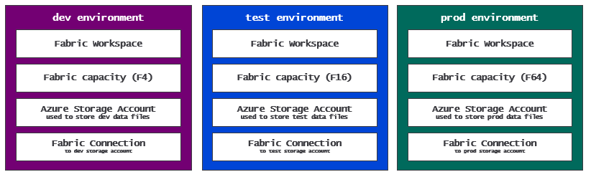
When using Terraform, it's recommended that you create a separate configuration for each environment. After all, you don't want a problem in the configuration for the dev environment or the test environment to affect the prod environment. You can create configurations for these environments using a provisioning flow to create resources in the following sequence.
- azurerm_fabric_capacity: create Fabric capacity
- fabric_workspace: create workspace assigned to capacity
- fabric_workspace_role_assignment: add workspace role assignments for access control
- azurerm_storage_account: create Azure storage account
- azurerm_storage_container: create container in Azure storage account for environment-specific data files
- azurerm_storage_account_blob_container_sas: create SAS token as credential to access storage container
- fabric_connection: create Fabric connection used to access data files in storage account
- fabric_connection_role_assignment: add connection role assignment to configure connection permissions
This example demonstrates how Terraform simplifies the setup process for building out the environments for a Fabric CI/CD project. This example also shows how Terraform helps to manage security and governance. For example, the Terraform configuration automatically handles configuring permissions and access to resources. If anything changes in the future with respect to permissions or access control, you can simply update the configuration and then run the terraform apply command.
There is a second aspect to this example which demonstrates another security-related best practice. The configuration creates a credential in the form of a SAS token and then uses that credential to create a Fabric connection. This is a best practice because it eliminates any need to share credentials with other humans or external processes. The Terraform configuration manages credentials behind the scenes in a state file that is locked down and encrypted in cloud storage. Terraform creates the connection, configures its permissions and pass the connection id back to you as output.
Resources for Terraform
- Terraform Documentation
- Terraform on Azure documentation
- Microsoft Fabric Provider

Fabric CLI
Fabric CLI is a developer tool that offers the easiest path to writing automation logic to complete tasks in Fabric for DevOps and CI/CD. At a high level, Fabric CLI acts as a façade which abstract away the underlying Microsoft APIs to provide a single, focused experience to assist with Fabric automation. Fabric CLI adds value by shielding you from having to worry about Entra Id authentication, access token acquisition and the execution of HTTP requests. Fabric CLI also simplifies running automation logic under the identity of a service principal.
Fabric CLI is a is a command-line interface tool that supports both an interactive mode and a scripting mode. The interactive mode makes it quick and easy to type and execute a sequence of commands. For example, you can use Fabric CLI in interactive mode to create a new workspace and then to create a lakehouse inside that workspace. Fabric CLI also provides commands to load data into lakehouse tables and to automate running notebooks and pipelines which contain ETL logic.
Fabric CLI scripting mode makes it possible to write and version automation logic for a Fabric CI/CD project. For example, you can use a shell script or a programming language such as PowerShell or Python to execute a sequence of Fabric CLI commands. If you decide not to use Terraform, you can write scripts which call Fabric CLI commands to create and manage tenant-level items such as workspaces, capacities, connections, domains and gateways.
Fabric CLI offers rich support for creating and managing workspace items. For example, Fabric CLI provides commands such as create, get, set and rm to perform CRUD operations on workspace items. There are also two Fabric CLI commands that allow you to work with an item definition. Fabric CLI provides an import command used to create or update a workspace item using an item definition. There is also a complimentary export command used to export a workspace item to an item definition as a set of definition files in a local folder.
Another important capability of Fabric CLI is its ability to integrate with cloud-based GIT providers such as Azure DevOps and GitHub. If you're developing workflows using GitHub workflow actions, it's relatively straight forward to install and load Fabric CLI executable which enables you develop workflows using Fabric CLI commands. If you're developing workflows using Azure pipelines, you can use the Microsoft Fabric Extension for Azure DevOps which adds the FabricCLITask@0 task which automatically provisions the Fabric CLI into the pipeline agent without requiring manual installation.
Links for more information about Fabric CLI
- Fabric CLI
- CLI Modes
- Fabric CLI Commands
- Fabric CLI Usage Examples
- Microsoft Fabric Extension for Azure DevOps

Semantic Link Labs
Semantic Link is a capability in Microsoft Fabric that bridges the gap between data science and data analytics by connecting Power BI semantic models with Python and Spark environments. Semantic Link allows data scientists to load the data from a semantic model into a FabricDataFrame object which can be used directly with many popular data science libraries such as pandas and scikit-learn.
Semantic Link Labs is a Python library designed for use in Fabric notebooks which provides access to Semantic Link for developers working in Fabric. However, Semantic Link Labs goes far beyond just wrapping Semantic Link. It adds a significant amount of functionality for working with workspace item such as semantic models, reports, lakehouses, notebooks and variable libraries. The goal is the Semantic Link Labs library is to simplify technical processes, empowering developers to focus on higher-level activities.
Beyond the scenes, Semantic Link Labs completes its work by calling to public Microsoft APIs such as the Fabric REST APIs, Power BI REST APIs and the Tabular Object Model. Developers using Semantic Link Labs benefits from the simplicity of a single API surface without having to think about the details of acquiring access tokens and dispatching calls to multiple APIs.. It extends the capabilities of Semantic Link, offering additional functionality to seamlessly integrate and work alongside it.
Semantic Link Labs provides the ability to work with workspace items from the Data Engineering workload such as lakehouses, notebooks and environments. Semantic Link Labs simplifies creating lakehouses and notebooks and configuring a notebook to use a specific lakehouse as its default lakehouse. There is also support for running jobs for notebooks and pipelines and monitoring job execution to determine whether the job completed successfully.
If you plan on using the Semantic Link Labs library. You must keep in mind that it only works inside the Fabric environment. You cannot load the Semantic Link Labs library in a non-Fabric environment such as Azure pipelines or GitHub Actions workflows. In order to leverage Semantic Links Labs from a non-Azure environment, you must maintain code which uses Semantic Link Labs in a Fabric notebook and then automate running the notebook.
Semantic Link Lab Resources
- Semantic Link Labs Code Examples
- Semantic Link Labs FAQ

Building a release process
Earlier you learned the fundamentals of building a development process using feature branches and feature workspaces. The goal of the development process is to create a single source of truth in the integration branch that is always ready for deployment. Now it's time to turn your attention to what comes next. You must build a release process to complete the full CI/CD lifecycle. The question now becomes how to deploy a Fabric solution to workspaces in environments for testing and production.
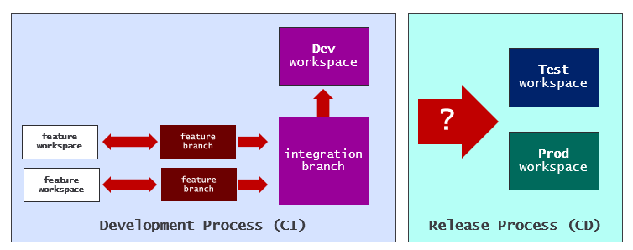
The first and easiest option for building a release process is using a Deployment Pipeline. Deployment Pipelines offer a low-code approach that can be a good fit for small to medium-sized projects, especially those exclusively focused on semantic models and Power BI reports.
As mentioned earlier, Deployment Pipelines assist with building a release process and not a development process. When you choose to use a deployment pipeline in a Fabric CI/CD project, you still need to plan how to build a development process. At a minimum, you should connect the first workspace in a deployment pipeline to a GIT branch just to gain the basic CI/CD capability such as versioning items and reverting to an earlier versions of an item if something goes wrong with an update.
The following diagram shows a deployment pipeline with the first workspace connected to the main branch in a GIT repository. In the simplest development scenario you can make direct updates to items in the dev workspace and then use Commit to GIT operations to commit changes to GIT where they can be used to revert to earlier item versions when necessary.
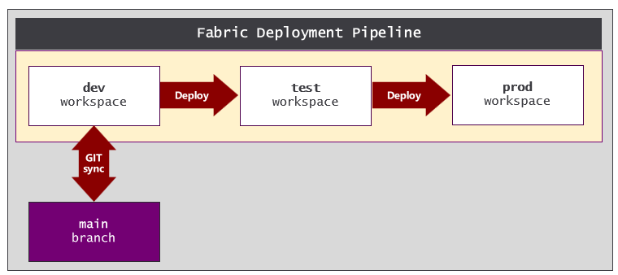
If you decide to build the release process using a Deployment Pipeline, you still have the ability to design a scalable development process using feature branches and feature workspaces. As an example, you can use the main branch as the integration branch for your development process. This makes it possible to create new feature workspaces by using the Branch out to workspace command to branch out from the dev workspace. As changes are committed and merged to the main branch using a pull request, the changes can be synchronized to items in the dev workspace using an Update from GIT operation. Once item-level changes have propagated to the dev workspace, they can be deployed across the other workspaces in the Deployment Pipeline using the Deploy command.
While Deployment Pipelines provides the easiest path to build a release process, they also have noteworthy limitations which limits their use in certain scenarios. For example, a Deployment Pipeline and all of its associated workspaces must exist inside the same Entra Id tenant. If you have a requirement create the dev workspace in one Entra Id tenant and the prod workspace in another, you cannot use deployment pipelines to build your release process.
There are some other factors to consider as well when deciding whether to use deployment pipelines. Setting up a Deployment Pipeline always requires some degree of manual configuration because certain setup tasks are not supported through public APIs. Deployment Pipeline are also limited when it comes to setting up manual approval processes. This is especially true when compared to what's possible with pull requests and approval gates in a GIT repository. Moreover, deployment pipelines are not well suited to handle larger projects where there are workspaces containing 100s of items.
A second option for building a release process using GIT synchronization. For example, you can use a GitFlow branching strategy in which a GIT repository is configured with three long-lived branches named dev, test and main. The dev branch serves as the integration with code ready for deployment. Pull requests are used push changes to the test branch and to the main branch which act as dedicated release branches. You can then use an Update from GIT operation to deploy changes from a release branch to its target workspace.
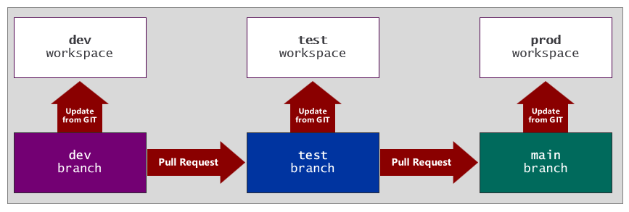
There are two important issues to consider when deciding whether to build a release process using GIT synchronization. First, there are issues caused by environment-specific settings that have been committed to GIT. For example, the datasource location for semantic models in the dev workspace will be committed to GIT and then propagated to semantic models in the test workspace and the prod workspace. That means you need to run a script after an Update from GIT operation completes to update each semantic model with the datasource path that is appropriate for its target environment.
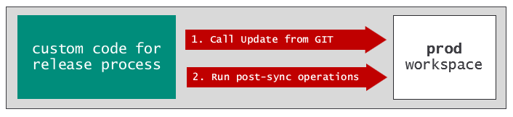
A second issue with GIT synchronization is that it requires a connection between the target workspace and a GIT branch. When a workspace is connected to a GIT branch, the Fabric user interface lights up the workspace with indicators and messages to control and monitor GIT synchronization. For example, the workspace summary page displays the Status column with values such as Synced or Update required which you might prefer to hide from users in a production workspace.
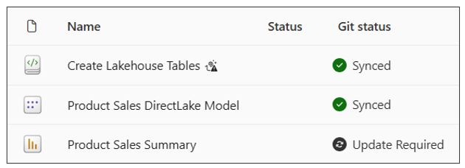
The third option for building a release process is using an API-driven approach. Using an API-driven approach has become increasingly popular because it offers significant advantages over the other two choices. For example, API-driven approach is much better from a performance perspective because it can scale to accommodate larger project in which workspaces contains 100s of items.
Using an API-driven release process also provides the flexibility to use whatever GIT branching strategy your organization prefers. Some organizations prefer using a GitFlow branching strategy while other organizations have standardized on trunk-based development. Once you've chosen a branching strategy, you can then adapt an API-driven release process to accommodate it.
In theory, you could spend the time and energy required to implement a release process using the Fabric REST APIs. However, this would require a non-trivial coding effort. Fortunately, there's a much better option to build a release process which is leveraging the fabric-cicd library. You will learn about the fabric-cicd library in greater depth in the next section. Before that, we'll examine how the fabric-cicd library can be used with popular branching strategies.
Consider the release process shown in the following screenshot which uses a GitFlow branching strategy. The dev branch serves as integration branch. This release process uses pull requests to push changes to test and main which serve as release branches. The use of pull requests makes it possible to configure manual approval processes and to trigger workflows that runs when a pull request completes. When a pull request completes and merges its changes to one of the release branches, a workflow runs automatically and implements the release process by using fabric-cicd to deploy changes to the target workspace.
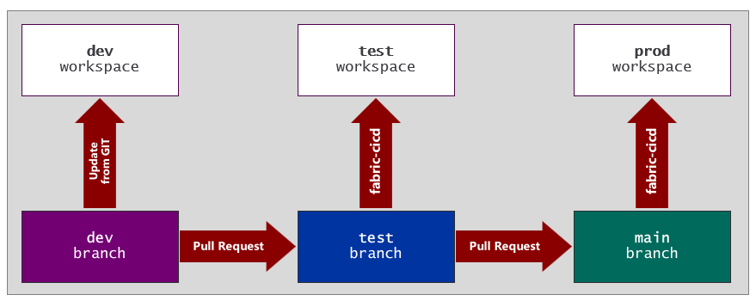
This example is similar to Git synchronization example shown earlier in the sense that they both use the GitFlow branching strategy. However, there are significant benefits in using fabric-cicd over GIT synchronization when building a release process. The first benefit is that fabric-cicd supports parameterization which makes it possible to dynamically update environment-specific settings as part of the deployment process. Compare this to GIT synchronization which pushes these types of environment-specific settings to items in the target workspace which then requires additional automation after an Update from GIT operation completes to apply a fix.
Now let's examine building a release process using a different branching strategy. Consider a scenario in which an organization has standardized on trunk-based development using a branching strategy based on a single long-lived branch. The following diagram show a release process in which the main branch acts as both the integration branch and the release branch. The fabric-cicd library provides the flexibility of building a release process with a one-to-many mapping between a release branch and multiple target workspaces.
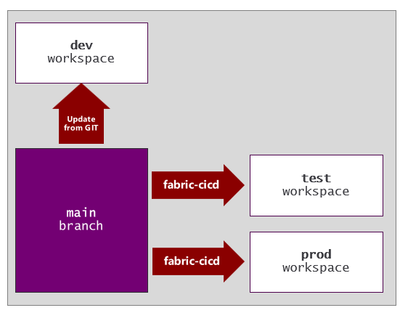
When building a release process, you are often required to configure a manual approval process in which one or more approvers need to sign off on a release before it's deployed to a target workspace. When using a GitFlow branching strategy, it's easy because you can configure pull requests with whatever manual approval process is required. However, things are not as obvious when using trunk-based development because the release process doesn't involve pull requests.
Fortunately, Azure DevOps and GitHub provide another way to configure a manual approval process without using pull requests. The way to accomplish this is by extending a GIT repository by creating environments. An environment in a GIT repository acts as a deployment target which can be configured with a manual approval process. When you run a workflow that targets an environment which has been configured with a manual approval process, the workflow is paused until the approval process completes. Once the approval is complete, the workflow resumes and can use the fabric-cicd library to deploy the new release to the target workspace.

The fabric-cicd library
fabric-cicd is an open-source Python library designed by Microsoft to enable code-first deployment. Code-first deployment is based on the idea that you can create the single source of truth for a Fabric solution by assembling a set of item definitions. Once you've assembled the item definitions for a Fabric solution in a root folder, you can then use these item definitions as templates to deploy a matching set of items to a target workspace.
While fabric-cicd is an open source project, it's officially supported and recommended as a best practice by the Fabric product team. You can have confidence that fabric-cicd will continue to evolve along with the Fabric platform.
A stated goal of the fabric-cicd project is to assist CI/CD developers who prefer not to interact directly with the Fabric REST APIs. You will find that running a deployment job with fabric-cicd only requires a few lines of code. However, the logic this library provides is quite mature as its been continually refined over the last few years. Let's walk through a few examples of how fabric-cicd works internally to give you an appreciation for how much work it does on your behalf.
To run a deployment job using fabric-cicd, you must supply two important input parameters. The first parameter points to a root folder containing items definitions. The second parameter references a target workspace. When you start a deployment job, fabric-cicd starts by enumerating through the root folder to discover every item definition including those item definition in child folders. For each item definition that fabric-cicd discovers, it must run a check on the target workspace to determine whether a matching items already exists. This check is required so fabric-cicd can decide whether to create a new item or to update an existing item.
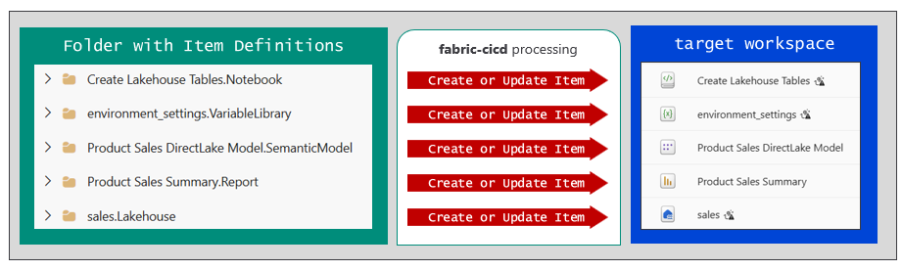
fabric-cicd is able to automatically reestablish relationships for items that support auto-binding. The fabric-cicd library implements auto-binding behavior in a manner similar to GIT synchronization by using the logicalId found in the platform file of an item definition. When a fabric-cicd deployment job runs, it uses the logicalId to map out and rebind item dependencies between items in the target workspace.
When fabric-cicd runs a deployment job, it processes items in a specific sequence to deal with item dependencies. After all, fabric-cicd cannot create an item with a dependency until after it has created the items on which it depends. As an example, notebooks can have dependencies on lakehouses. Pipelines can have dependencies on lakehouses and on notebooks. The fabric-cicd deals this dependency tree using a sequence which deploys lakehouses first followed by notebooks and then pipelines. The fabric-cicd library even includes logic to detect whether any pipelines have dependencies on other pipelines. The sequencing ensures that pipelines with dependencies are always deployed after other pipelines on which they depend.
Now that understand how fabric-cicd works, let's more ahead and walk through an example running a deployment job. You can start by adding a pair of YAML files to the same root folder which holds the item definitions for a Fabric solution. The first file named deploy.yml allow you to configure settings for fabric-cicd deployment jobs. The second file named parameter.yml is used to configure parameterization to deal with environment-specific setting that have been committed to GIT.
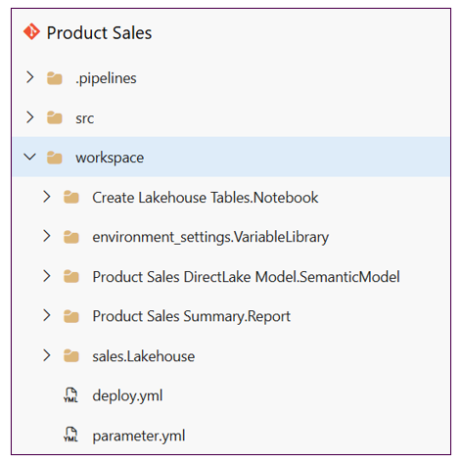
Let's walk through a simple example of configuration-based deployment using fabric-cicd. We'll start by examining the contents of a simple configuration file named deploy.yml. The YAML content contains a top-level key named core which has child keys named workspace_id, repository_directory, item_types_in_scope and parameter. Underneath the workspace_id key, there are two subkeys named test and prod which define target environments for a deployment job.
core:

workspace_id:
test: "400c3329-53b6-415d-a663-d7f1ec73c171"
prod: "c1932962-8236-4375-ad3b-0f3a14dc4c13"

repository_directory: ","

item_types_in_scope:
- VariableLibrary
- Lakehouse
- Notebook
- DataPipeline
- SemanticModel
- Report

parameter: "parameter.yml"
Targets environments are an important concept when using fabric-cicd. The configuration shown in this example defines two target environments named test and prod. The configuration maps each environment to a target workspace using a unique workspace_id value. Whenever you start a deployment job, you must pass a parameter indicating which environment you want to target. You will experience an error if you try to start a deployment job using an environment name hasn't been defined in deploy.yml.
fabric-cicd provides special treatment when deploying variable libraries. If your solution contains a variable library, fabric_cicd will always deploy it first before any other items that depend on it. After creating a variable library, fabric-cicd goes one step further making it possible to activate a specific value set. You should be aware that value set activation requires you use matching names between environment passed to fabric-cicd and the name of the value set to be activated. If you run a fabric-cicd deployment job with a target environment name such as test or prod, you must ensure the variable library also contains value sets with the matching names of test or prod.
Now let's walk through writing the Python code required to start a fabric-cicd deployment job. First, you must install the fabric-cicd library which is available in the Python Package Index (PyPI). That means you can install fabric-cicd using the pip install command.
pip install fabric-cicd
The fabric-cicd library is commonly used to build release processes in workflows that run in Azure DevOps or in GitHub. Fortunately, the ability to install on demand using pip install makes it easy to integrate fabric-cicd with Azure pipelines or GitHub Custom Actions.
The following Python code demonstrates how few lines of code it takes to run a deployment job with fabric-cicd. First, you need to create credentials to authenticate with an Entra Id security principal. This example demonstrates authenticating as service principal using credentials stored in environment variables. You start a deployment job by calling the deploy_with_config function and passing parameter values for token_credential, config_file_path and environment.
from azure.identity import ClientSecretCredential
from fabric_cicd import deploy_with_config

# create credentials to authenticate as service principal
spn_credential = ClientSecretCredential(
tenant_id = os.getenv('AZURE_TENANT_ID'),
client_id = os.getenv('AZURE_CLIENT_ID'),
client_secret = os.getenv('AZURE_CLIENT_SECRET')

# deploy to test workspace
deploy_with_config(
token_credential = spn_credential,
config_file_path = './workspace/deploy.yml',
environment = 'test'
)

# deploy to prod workspace
deploy_with_config(
token_credential = spn_credential,
config_file_path = './workspace/deploy.yml',
environment = 'prod'
)
When calling deploy_with_config, you must pass an environment value which maps to target environment defined in deploy.yml. The environment name determines the id of the target workspace. The ability to define multiple deployment targets in configuration is powerful because it allows you to build a release process with a one-to-many mapping between a single release branch and multiple target workspaces. The previous code listing demonstrates how easy it is to switch between deploying to the test workspace and the prod workspace. You just need to pass a different environment name when calling deploy_with_config.
Now it is time to examine the fabric-cicd support for parameterization which makes it possible to dynamically update settings in item definition files during a deployment job. This parameterization support is essential because it provides a reliable way to deal with environment-specific settings that have been committed to GIT.
Consider an example of a semantic model that connects to an Azure storage account but requires different datasource paths for the three environments dev, test and prod. The problem is that the datasource path for the semantic model in the dev workspace is committed to GIT in the integration branch. Parameterization is required to ensure that the semantic models in the test workspace and the prod workspace are updated with their environment-specific datasource paths.
The following YAML listing demonstrates configuring parameter.yml with find-and-replace operation. There is a top-level key named find_replace with nested keys named find_value and replace_value. The find_value key is assigned a string value from the dev workspace that you want to replace. The replace_value key contains a nested key-value pair for each target environment. In this example, the configuration defines two target environments named test and prod.
find_replace:

- find_value: "https://storage4dev.dfs.core.windows.net/productsales/"
replace_value:
test: " https://storage4test.dfs.core.windows.net/productsales/"
prod: " https://storage4prod.dfs.core.windows.net/productsales/"
By default, fabric-cicd processes a find_replace operation by inspecting every file in every item definition whose type is include in the item_type_in_scope property setting. This can lead to longer processing times in scenarios in which you have a large number of items or you have item definitions such as a semantic model with a large number files.
To optimize performance, fabric-cicd parameterization allows you to define filters to control which items and files are examined during a replacement operation. For example, you can extend the find_value key by adding filtering keys such as item_type, item_name and file_path. The following configuration demonstrates how to filter a find_replace operation to restrict processing to a single file named expressions.tmdl found in the item definition for a single semantic model identified by its display name.
find_replace:

- find_value: "https://storage4dev.dfs.core.windows.net/productsales/"
replace_value:
test: " https://storage4test.dfs.core.windows.net/productsales/"
prod: " https://storage4prod.dfs.core.windows.net/productsales/"
item_type: "SemanticModel"
item_name: "Product Sales Imported Model"
file_path: "/definition/expressions.tmdl"
The parameterization support in fabric-cicd goes beyond adding simple find-and-replace operations. fabric-cicd also supports parameterization using regular expressions and dynamic variables. In order to demonstrate these advanced parameterization capabilities, let's examine a common scenario in which a semantic model is designed to connect to the SQL endpoint of a lakehouse in the same workspace. This scenario requires parameterization because each semantic model requires a uniuqe datasource path to references the SQL endpoint for the lakehouse in the same workspace.
The item definition for the semantic model includes an expressions.tmdl file which connects to the SQL endpoint using a call to the PowerQuery function name SQL.Database. The SQL.Database function accepts two parameters. The first parameter is for the SQL endpoint server path and second parameter references a lakehouse.
Sql.Database(<SQL Endpoint Connect String>, "12341234-1234-1234-1234-123412341234")
Let's start by looking at the second parameter passed to SQL.Database which is used to identify the target lakehouse. For this lakehouse parameter, you can pass the either the lakehouse id or the lakehouse display name. Using the lakehouse id is problematic because it will always be different across envorinemnts requiring additional parmeterization. Instead, you should always pass the lakehouse name instead of the lakehouse id. That's because the lakehouse name will be the same across all environments eliminating the need for parametization.
Sql.Database(<SQL Endpoint Connect String>, "sales")
Now let's turn our attention to the first parameter passed to Sql.Database. This parameter is used to pass the SQL endpoint connect string which ends with .datawarehouse.fabric.microsoft.com . However, the first part of the SQL endpoint connection string is always unique to a specific workspace which means. Therefore, dealing with the SQL endpoint connection string requires parameterization.
Sql.Database(4zzdkw4hunvuhp4ttpl5hvkkzm-6pexp5fkuvjedkrx773mxow6z4.datawarehouse.fabric.microsoft.com,
fabric-cicd supports parameterization using regular expressions to identity capture zones used in find_replace operations. The following regular expression demonstrates defining a capture zone for the SQL endpoint connection string.
Sql\.Database\(\s*"([^"]*datawarehouse\.fabric\.microsoft\.com[^"]*)"\s*,
Once you have created the regular expression with a capture zone to replace the SQL endpoint connection string, you can use it in a find_replace operation as long as you add an is_regex key with a value set to true.
find_replace:

- find_value: 'Sql\.Database\(\s*"([^"]*datawarehouse\.fabric\.microsoft\.com[^"]*)"\s*,'
replace_value:
test: $items.Lakehouse.sales.$sqlendpoint
prod: $items.Lakehouse.sales.$sqlendpoint
is_regex: "true"
item_type: ["SemanticModel"]
file_path: "**/expressions.tmdl"
In addition to demonstrating the use of a regular expression with a capture zone, this example also uses a dynamic variable for the replace_value key. The dynamic variable is created to reference the lakehouse names sales using the syntax $items.Lakehouse.sales. In this example, the $sqlendpoint property of the dynamical lakehouse variable is used to provide the replacement value.
There is one final improvement that can be made to this example. In the previous listing, you can see that both environments use the same dynamic variable expression as the replace_value. In a scenario like this in which all environment keys have the same value, you can use the _ALL_ key instead of adding multiple environment keys with redundant values.
find_replace:

- find_value: 'Sql\.Database\(\s*"([^"]*datawarehouse\.fabric\.microsoft\.com[^"]*)"\s*,'
replace_value:
_ALL_: $items.Lakehouse.sales.$sqlendpoint
is_regex: "true"
item_type: ["SemanticModel"]
file_path: "**/expressions.tmdl"
This example demonstrates the power of configuring parameterization using regular expressions, capture zones and dynamic variables. Keep in mind you can use dynamical variables to obtain the id for any type of workspace item. You can also use a dynamic $workspace variable which provides the $id property and the $name in cases in which you need to obtain the id or name of the current workspace.
Resource for learning more about fabric-cicd
- Home page
- Code Samples
- Code Reference
- Parameterization

Data orchestration
Fabric provides rich support for building data-centric solutions. This support is built on top of one set of workspace item types that act as a data containers and a complimentary set of workspace item types which focus on running ETL processes and data integration. When designing a Fabric solution with a data container item such as a lakehouse, you must plan how to build and run a ETL logic to populate the lakehouse. You can choose between several different types of ETL-focused item types such as notebooks, pipelines, copy jobs, user-defined functions. Dataflows and Spark Job Definitions.
This guidance does not intend to provide in-depth coverage of how to build and optimize ETL processes in Fabric or how to choose between notebooks versus pipelines versus dataflow. Instead, this guidance calls out a few general best practices for designing the ETL logic in a Fabric solution that you intend to deploy to multiple target environments.
It is a best practice to author and maintain the ETL logic for a Fabric solution using workspace items that are part of the same solution. When you build ETL logic using workspace items such as notebooks or pipelines, the ETL logic can be tracked in a GIT branch and versioned over time along with all other items in the Fabric solution. For this reason, it's recommended that you avoid designing Fabric solutions that depend on external ETL processes or scripts that are not part of the current solution.
Another essential best practice is to plan a data orchestration strategy to populate items that act as data containers such as a lakehouse. The goal is to is design a set of ETL-based items to automate data ingestion, transformation and persistence as part of the solution deployment process. Let's examine why having this type of strategy is important.
As you know, you have several different options for deploying a Fabric solution with a lakehouse to a target workspace. One option is to deploy the Fabric solution from one workspace to another using a deployment pipeline. A second option is to deploy the Fabric solution when branching out to a feature workspace using an Update from GIT operation. A third option is to deploy the Fabric solution using the fabric-cicd library. Whichever of these three options you choose, the deployment result will always be the same. The lakehouse is created as an empty data container which requires your attention.
Let's walk through an example of data orchestration in a Fabric solution shown in the following diagram. This solution is designed with a medallion architecture in which data flows across three lakehouses which serve as storage for the bronze, silver and gold layers. The bronze lakehouse is designed with an ADLS Gen2 shortcut to enable access to data files in an Azure storage account container. There is one notebook which builds the silver layer by loading the data files from the bronze lakehouse and persisting them as delta tables in the silver lakehouse. There is second notebook which builds the gold layer by loading tables from the silver lakehouse and transforming them into a star schema before saving them as delta tables in the gold lakehouse.
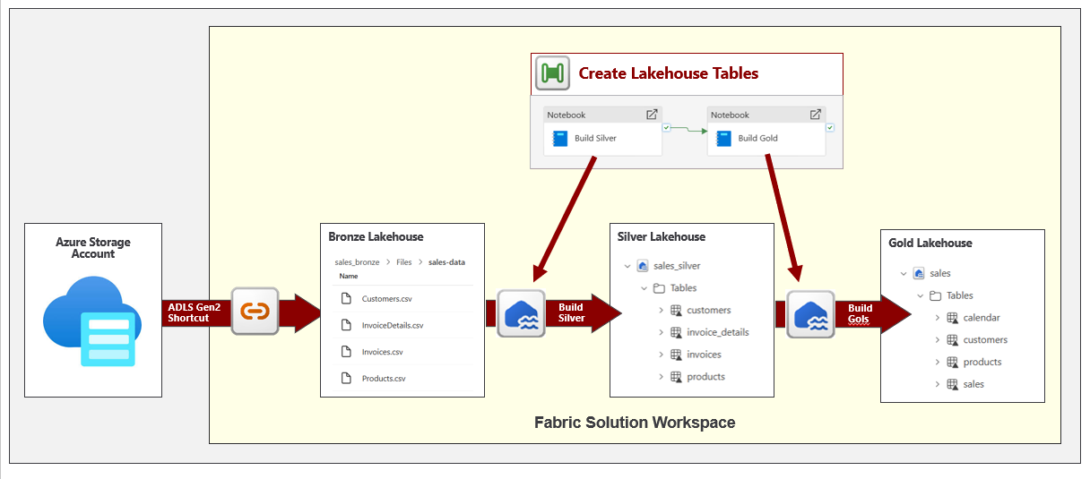
An important aspect of this data orchestration design is that it exposes a top-level pipeline named Create Lakehouse Tables. When you run this pipeline, it runs the two notebooks in sequence to execute all the necessary ETL logic to populate all lakehouses with data. After you deploy this Fabric solution which creates lakehouses in an empty state, you can then automate running this pipeline to execute the data orchestration which moves the workspace into a state where it's ready for use.
To summarize this best practice, a Fabric solution should expose a single item with top-level ETL logic which can be run to populate data container items with data. Whether you implement a data orchestration strategy using notebooks versus pipelines versus something else is up to you. What's important is that when you first deploy a Fabric solution, you can follow up deployment by running a single job with the data orchestration required to prepare the workspace so it's ready for users. When a Fabric solution includes a top-level notebook or pipeline, you can automate running it after a deployment using fabric-cicd.
When designing a data orchestration strategy, you must also consider data refresh requirements. Think about what happens after the initial deployment once data container items have been populated with data for the first time. How do you plan to keep the data in a lakehouse up to date? The recommended approach is to automate the processes for refreshing data using scheduled jobs.
For example, you could schedule a pipeline that processes a full data refresh to run once a day while designing another pipeline with incremental refresh logic to run as a scheduled job to run every 15 minutes. The key point is that adding scheduled jobs should be part of the data orchestration plan because it enables a Fabric solution to self-manage all its data refresh requirements.
Fabric makes it possible to extend the item definition of notebooks and pipelines using a .schedules file. The .schedules file contains JSON content with a schedules element containing a list of one or more scheduled jobs. By extending the item definitions for ETL items in a Fabric solutions with .schedules files, you can automate the data refresh strategy for a Fabric solution.
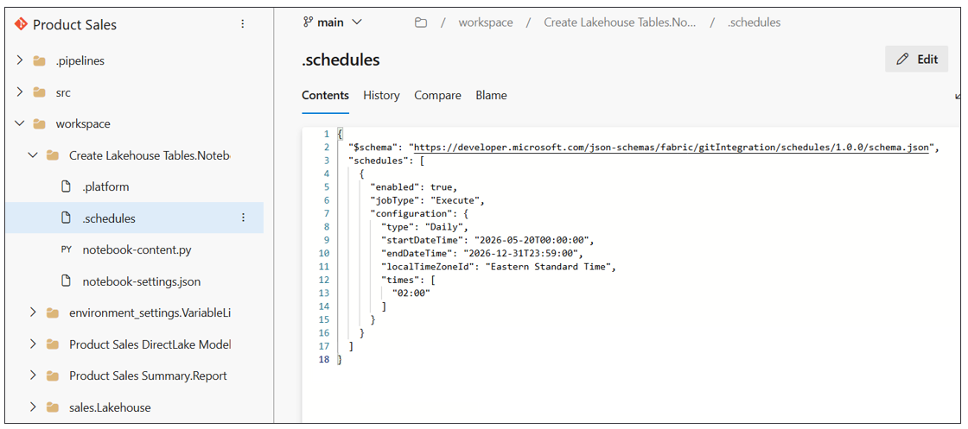
One final issue to consider with data orchestration is how to address changes to schemas over time. Think about a scenario where need to update the table schema for a lakehouse that's already been deployed and populated with data. Pushing out table schema changes to a lakehouse is challenging because Fabric doesn't track any metadata for the table schema in the underlying item definition for a lakehouse. The most common way to update the table schema for a lakehouse is a run a notebook with procedural programming logic to add and remove tables and table columns.
Now imagine you begin working in a feature workspace to write code in a notebook to update the lakehouse table schema. First, you write the code and test it using a lakehouse in the feature workspace. After than, you commit your changes to GIT and use a pull request to push the notebook to the integration branch. Now you can use an Update from GIT operation to push the notebook to the dev workspace. Likewise, you can use fabric-cicd to push the notebook to the test workspace or the prod workspace. However, just pushing the notebook to the workspace with the lakehouse is not enough. You still need to actually run the notebook in the target workspace to update the lakehouse schema.
Managing schema and pushing schema changes with Fabric warehouse is much different than lakehouse. The best practice for implementing CI/CD processes with a warehouse schema is using SqlPackage and DacFx.

Fabric REST API Programming
Fabric offers several developer tools and libraries that are effective in boosting your productivity. You have seen examples of Terraform, Fabric CLI, Semantic Link Labs and fabric-cicd which hide many of the low-level details associated with authentication, acquiring access tokens and executing HTTP requests. However, you might encounter scenarios in which you need a greater degree of control. This can be achieved by programming the Fabric REST API to execute API calls using a familiar programming language such as C# or Python.
This guidance recommends using Terraform to create infrastructure in larger Fabric CI/CD projects. But there could be factors that make you decide against using Terraform in a particular Fabric CI/CD project. As an alternative, you can write automation scripts which call the Fabric REST APIs to create tenant-level Fabric items such as workspaces, connections, gateways and deployment pipelines. Using Fabric REST APIs also makes it possible to fully automate the process setting up GIT integration for a Fabric CI/CD project. This is achieved by creating a GIT source control connection and then using that connection to bind workspaces to GIT branches.
Programming the Fabric REST APIs provides the richest support for managing the lifecycle of workspace items. This is due to the ability to work directly with items definitions when calling CRUD APIs to create and update workspace items. This makes it possible to deploy a Fabric solution to a target workspace using a repeatable process which ensures workspace items are created with the correct relationships to other items in the same workspace. For example, you can create a lakehouse and a notebook in such as way that the notebook is configured to use the new lakehouse as its default lakehouse.
The Fabric REST APIs can be used to control GIT synchronization. There is an Update From Git API which can be used to initialize or update a feature workspace from an underlying GIT branch. It's also common to call Update From Git on the dev workspace to synchronize changes merged from feature branches to the integration branch. There is a complimentary Commit To Git API used in scenarios in which you need to automate the commit operation to push workspace item changes to its underlying GIT branch.
If you decide to program directly against the Fabric REST APIs, there are a few fundamental you need to learn right away. The Fabric REST APIs are built upon three essential concepts which are paginated results, long-running operations (LRO) and throttling. Developers who choose to program the Fabric REST APIs must understand these concepts in order to write code that is correct and reliable. Fortunately, this is something you don't have to worry about when using developer tools such as Terraform and Fabric CLI which deal with paginated results, long-running operations and throttling behind the scenes.
Fabric REST API Fundamentals
- The Fabric REST APIs
- Fabric GIT APIs
- Pagination
- Long running operations
- Throttling
Microsoft offers two Software Development Kits (SDKs) for the Fabric REST APIs. Microsoft provides a Microsoft Fabric .NET SDK for C# developers and a Microsoft Fabric Python SDK for Python developers. These SDKs provide a productivity boost by hiding low-level details for executing HTTP requests, transmitting access tokens and converting back and forth between JSON and strongly-typed objects. The two SDKs also provide the convenience of dealing with paginated results, long running operations and throttling errors behind the scenes.
Let's examine a simple listing showing the traditional 'hello world' code for using the Fabric Python SDK to create a new workspace. This code begins by creating a ClientSecretCredential object which is used to authenticate as a service principal. After that, the code creates a FabricClient object named fabric_client which exposes methods to execute calls Fabric REST API endpoints. The code in the listing creates a workspace by calling create_workspace. After that, the code calls list_workspaces and uses the result to enumerate through the existing set of workspaces.
"""Hello World for Fabric REST API Pythn SDK"""

import os
from azure.identity import ClientSecretCredential
from microsoft_fabric_api import FabricClient

credential = ClientSecretCredential(
tenant_id = os.getenv("AZURE_TENANT_ID"),
client_id = os.getenv("AZURE_CLIENT_ID"),
client_secret = os.getenv("AZURE_CLIENT_SECRET")
)

fabric_client = FabricClient(credential)

# create request body for creating new workspace
create_workspace_request = {
"displayName": "Hello Python SDK",
"description": "This isn't so hard",
"capacityId": os.getenv("FABRIC_CAPACITY_ID")
}

# call Create Workspace API
workspace = fabric_client.core.workspaces.create_workspace(create_workspace_request)

# enumerate workspaces by calling List Workspaces API
workspaces = fabric_client.core.workspaces.list_workspaces()
for workspace in workspaces:
print(f'{workspace.display_name} - [{workspace.id}]')

Fabric REST API SDKs
- Microsoft Fabric .NET SDK
- Python SDK (coming soon)
Let's examine a Fabric REST API programming scenario in which you need to deploy a Fabric solution to a target workspace which involves creating a lakehouse and a notebook. In this scenario, assume you already have an existing item definition for a notebook and you need to create the notebook in such a way that it references the new lakehouse as its default lakehouse. This means you need to update the item definition file named notebook-contents.py with the lakehouse id before you can use the item definition to create the notebook.
There is a timing issue involved in this scenario. You cannot determine the new lakehouse Id until after the lakehouse has been created. Once the lakehouse has been created, you must then update the item definition file notebook-contents.py with the Id of the new lakehouse. The best way to deal with this scenario when programming with the Fabric REST APIs is loading the item definition files for the notebook into memory. Once you have loaded the contents of notebook-contents.py into memory, you can update it dynamically before using it to create a new notebook item. The ability to dynamically update an item definition file provides a more seamless experience when developing a Fabric solution where you're required to create a set of workspace items with dependencies between them.
The Fabric REST APIs offer three primary APIs which involve programming with item definitions. First, the Create Item API allows you to pass an item definition when creating a workspace item. Second, the Update Item Definition API allows you to pass an item definition when updating a workspace item. Third, the Get Item Definition API allows you to retrieve the item definition for an existing item.
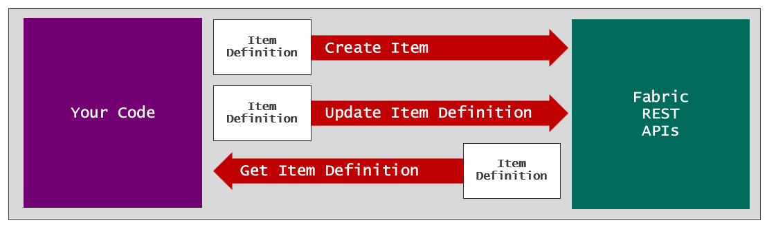
Let's walk through a scenario in which creating a workspace item requires dynamically updating an item definition file. Imagine you have just used the Fabric REST API to create a workspace and a lakehouse inside that workspace. Now it's time to create the notebook. However, you have to create a notebook in such a way that it's configured to use the lakehouse as its default lakehouse.
As discussed earlier, the notebook-content.py file in the item definition for a notebook contains metadata which tracks the configuration of its default lakehouse. The metadata is hidden from users when the notebook is opened in the web-based notebook editor provided by the Fabric service. However, you can view this metadata by examining the raw file contents of notebook-content.py file as shown in the following screenshot.
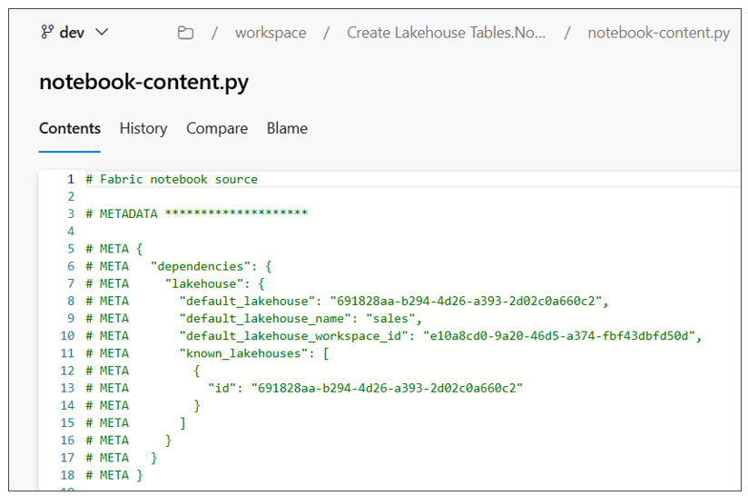
Before calling Create Item, you first need to update the contents of notebook-content to include the correct workspace id and lakehouse id. This means your code must track the ids of the workspace and the lakehouse as they are created. Once you have determined what the ids are, you can perform some type of find-and-replace operation to substitute the workspace id, lakehouse id and lakehouse display name into the contents of notebook-content.py.
# Fabric notebook source

# METADATA ********************

# META {
# META "dependencies": {
# META "lakehouse": {
# META "default_lakehouse": "{LAKEHOUSE_ID}",
# META "default_lakehouse_name": "{LAKEHOUSE_NAME}",
# META "default_lakehouse_workspace_id": "{WORKSPACE_ID}",
# META "known_lakehouses": [
# META {
# META "id": "{LAKEHOUSE_ID}"
# META }
# META ]
# META }
# META }
# META }
Directly manipulating item definition files is a powerful technique that assumes you know what you are doing. If you update an item definition file with invalid syntax, you will experience errors when calling Create Item and Update Item Definition.
Now let's walk through the programming steps required to call Create Item using an item definition. First, you need to enumerate through all the files in the item definition folder and load their contents and their relative files paths into memory. At this point you can updated the contents of notebook-content.py in memory with the metadata for the default lakehouse you'd like to use.
The next step is to parse together a JSON payload that allows you to pass the item definition across the network. Things get a bit tricky because there's a need to pass the contents of multiple files across the network in a single HTTP request. The way to accomplish this is to convert the contents of each file into a base64 encoded format. By formatting file contents using base64 encoding, you can add the content of any file into a JSON element as a standard string value. This makes it possible to transmit all the files required for an item definition across the network in a call the Create Item API.
The following JSON listing shows an example of an HTTP request body that can be passed across the network in a call to the Create Item API. The definition element contains a parts collection which contains a part element for each file in the item definition. Each part element includes a relative path value and a payload for the file contents in a base64 encoded format.
{
"displayName": "Create Lakehouse Tables",
"type": "Notebook",
"definition": {
"parts": [
{
"path": ".platform",
"payload": "********************BASE64-ENCODED-FILE-CONTENT********************"
"payloadType": "InlineBase64"
},
{
"path": "notebook-content.py",
"payload": "********************BASE64-ENCODED-FILE-CONTENT********************"
"payloadType": "InlineBase64"
},
{
"path": "notebook-settings.json",
"payload": "********************BASE64-ENCODED-FILE-CONTENT********************"
"payloadType": "InlineBase64"
}
]
}
}
At this point, you should be able to make an observation about the difference between Fabric REST API programming and using Fabric developer tools and libraries such a Terraform, Fabric CLI or fabric-cicd. Programming the Fabric REST APIs provides more control but at the expense of significantly more complexity. When you use Terraform, Fabric CLI or fabric-cicd, all the work of formatting file contents back and forth between base64 encoding and clear text is handled for you behind the scenes. While these tools and libraries don't provide as much control, they sure makes things a lot easier.
Consider another convenience provided by Terraform, Fabric CLI and fabric-cicd. You don't have to worry about whether target workspace items already exists or not because these tools and libraries contain logic to detect whether a target item already exists. To implement the same logic with the Fabric REST APIs requires multiple steps. First, you need to call the Get Items API to determine whether the target item exists. You must follow that with conditional logic which determines whether to call Create Item versus Update Item Definition.
Let's examine another common scenario in which you need to program the Fabric REST APIs to update an existing workspace item. Perhaps you'd like to update the metadata for an existing notebook to switch its default lakehouse from one lakehouse to another. You can accomplish this using the following steps.
- Call Get Item Definition to retrieve JSON response with the current item definition
- Extract the notebook-content.py file content and convert it from base64 to plain text
- Perform a find-and-replace operation on notebook-content.py to update the workspace id and lakehouse id
- Convert the updated file contents for notebook-content.py back into the base64 encoded format
- Update the JSON element for the item definition with the base64 encoded content for notebook-content.py.
- Call Update Item Definition passing the JSON with the updated item definition.
Resources for working with item definitions
- Fabric item definitions overview
- Create Item API
- Get Item Definition API
- Update Item Definition API
When you begin to program the Fabric REST APIs, you might notice that it provides item-generic APIs as well as item-specific APIs. You've already seen examples of using item-generic APIs such as Create Item and Update Item Definition. However, the Fabric REST APIs also offer item-specific APIs such as Create Lakehouse and Create Notebook. This begs the question should you use item-generic APIs or item-specific APIs.
With respect to creating, updating and deleting workspace items, it doesn’t really matter whether you use the item-generic APIs or item-specific APIs because the result will be the same. For this reason, many developers prefer using item-generic APIs to create and update workspace items because it allows them to write generic code which can be reused with any type of workspace item.
The only time where it's essential to use item-specific APIs is when you need to a query a workspace item to retrieve its properties. As an experiment, let's compare the results of calling Get Item versus Get Lakehouse. A call to Get Item results in an HTTP GET request to a URL which targets the items endpoint for a specific workspace.
https://api.fabric.microsoft.com/v1/workspaces/{workspaceId}/items/{itemId}
The response from Get Item returns a JSON element which contains properties common to all types of workspace items.
{
"displayName": "sales",
"description": "Contain for sales data",
"type": "Lakehouse",
"workspaceId": "{LAKEHOUSE_ID}",
"id": "{WORKSPACE_ID}"
}
Now let's compare this to a call to Get Lakehouse which uses an URL targeting the lakehouses endpoint for a workspace.
https://api.fabric.microsoft.com/v1/workspaces/{workspaceId}/lakehouses/{lakehouseId}
The response from Get Lakehouse includes a properties element with additional properties that are specific to lakehouses.
{
"displayName": "sales",
"description": "Contain for sales data",
"type": "Lakehouse",
"workspaceId": "{LAKEHOUSE_ID}",
"id": "{WORKSPACE_ID}"
"properties": {
"oneLakeTablesPath": "https://onelake.dfs.fabric.microsoft.com/{workspaceId}-{ItemId}/Tables",
"oneLakeFilesPath": "https://onelake.dfs.fabric.microsoft.com/{workspaceId}-{ItemId}/Files",
"sqlEndpointProperties": {
"connectionString": "{SQL_ENDPOINT_UNIQUE_PATH}.datawarehouse.fabric.microsoft.com",
"id": "{LAKEHOUSE_ID}",
"provisioningStatus": "Success"
}
}
}
There is a common scenario in which you need to create a lakehouse along with a semantic model which connects to that lakehouse using the OneLake URL or the SQL endpoint. After creating the lakehouse, you need to call the Get Lakehouse API to discover its properties so that you can update the semantic model with the correct connection settings.

Bulk Import/Export APIs
Content not yet available - coming soon!

Developing Workflows for Fabric CI/CD
Now that you've seen your options for writing automation logic for CI/CD processes, the next question to answer is where to deploy that code. The answer to this question is simple. You want to deploy the code which runs CI/CD processes in the same GIT repository that holds the item definitions. The next two sections will introduce the topic of developing custom workflows in the GIT providers supported by Fabric which are Azure DevOps and GitHub.

Developing Azure Pipelines
Azure DevOps is a Microsoft cloud platform that provides a suite of development tools for software teams to plan, build, test, and deploy applications. It's designed with CI/CD features to support the entire software development lifecycle. When you create a new project in Azure DevOps, the project is automatically created with a GIT repository of the same name. For example, creating a project named Product Sales will automatically create a repository named Product Sales.
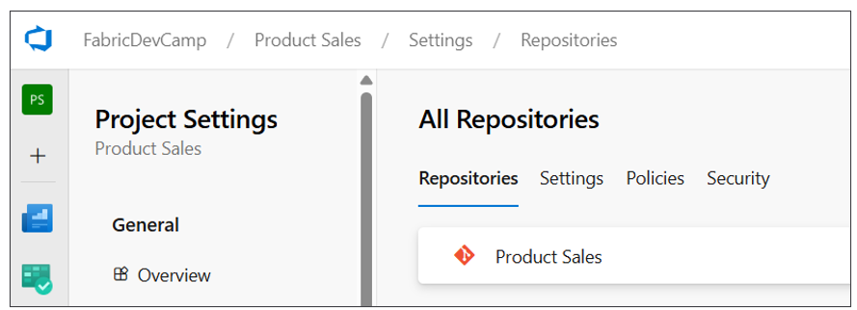
In many scenarios, the GIT repository that's created along with the project is all you need. However, you can always add additional repositories to a project if they're needed.
Azure Pipelines is the workflow development platform that's built into Azure DevOps. Azure pipelines provide the capability to integrate, test and deploy code using the principals of CI/CD. When you create an Azure pipeline, you can configured it to run on-demand or on a schedule such as every night at midnight. Alternately, you can define an Azure pipeline with a trigger to run automatically in response to a code commit or the completion of a pull request.
To create an Azure pipeline, you must first add a YAML file with a pipeline definition into your repository. Once you have added the YAML file, you must then explicitly register it with the Azure DevOps project for it to be recognized as an Azure pipeline. This registration can be accomplished through the Azure DevOps user interface or it can be automated using the Azure DevOps CLI or the Azure REST APIs. Once a pipeline has been registered, you should be able to see it in the Pipelines page in an Azure DevOps project.
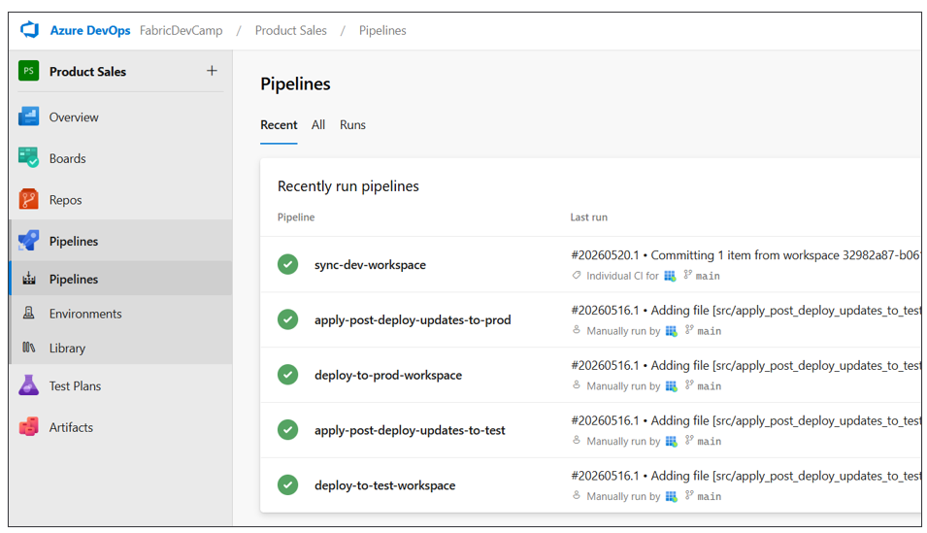
You can write the code for an Azure pipeline in a programming language such as Python. This is accomplished by referencing a script with Python code from the YAML file. The following screenshot shows an example of YAML files for Azure pipelines in the .pipelines folder and their associated Python scripts in the src folder. Below these two folders you can also see the workspace folder which contains the item definitions for a specific Fabric solution.
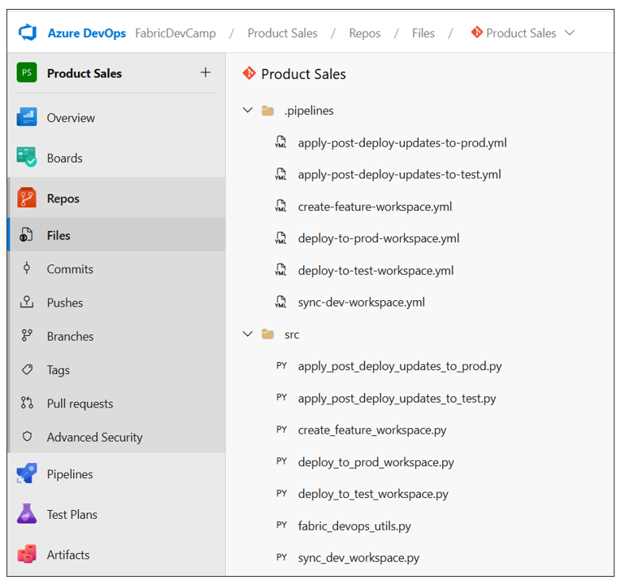
As you begin to develop Azure pipelines for a Fabric CI/CD project, you will find your code requires access to environment settings such as the ids for workspaces, capacities, users and groups. You might also need credentials for an Entra Id application to authenticate as a service principal. The Azure pipelines service allows you to create variables and secrets in order to make these types of environment settings available to the code in your workflows.
The way to create variables and secrets that are accessible to Azure pipelines is to create a variable group. Once you have created a variable group, you can then add a set of named variables along with their values. The following screenshot shows a typical set of variables and secrets created for Azure pipelines in a Fabric CI/CD project.
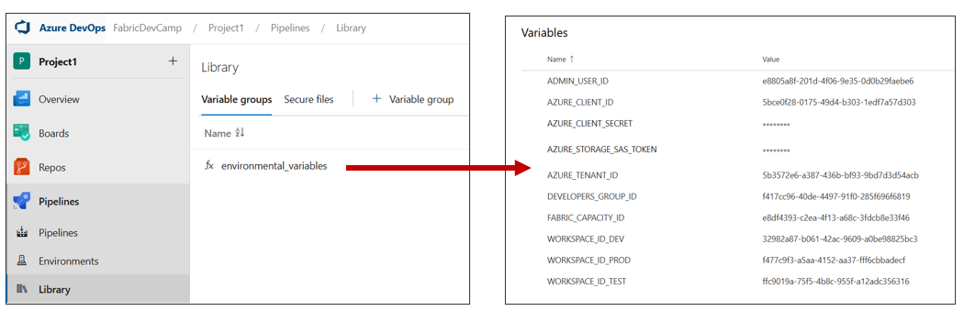
When you create a variable that contains sensitive data, you can mark that variable as a secret. For example, your pipeline might need to access to a client secret used to authenticate as a service principal. When you mark a variable as a secret, the Azure DevOps service does several important things to protect its value. First, the variable is persisted in the cloud using an encrypted format rather than plain text. Second, the value cannot be viewed in the Azure DevOps user interface after saving. Third, the secret value is masked in logs. If the secret value appears in pipeline output, Azure Pipelines replaces it with *** so it won't be visible to users or in build logs.
Variable groups in Azure DevOps can also be integrated Azure Key Vault. That means you can configure access to secrets in Azure Key Vault from code running in an Azure pipeline. This makes it possible to benefit from Azure Key Vault features such as conditional access policies, auditing, and secret rotation.
By default, an Azure pipeline does not have access to the variables in a variable group. Instead, you must configure permissions for a variable group to ensure the code in your Azure pipelines has access to its variables and secrets. These permissions can be configured using the Pipeline permissions dialog in the Azure Devops user interface or by using the Azure DevOps CLI or the Azure REST APIs.
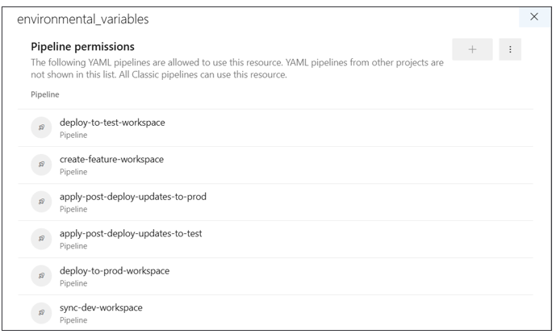
When building a release process using an Azure pipeline, you are often required to configure a manual approval process. This can be tricky when using trunk-based development because the release process doesn't involve pull requests. However, you can solve the problem by creating environments which can be configured with a manual approval process. As an example, you can extend an Azure DevOps project by adding two environments named test and prod.
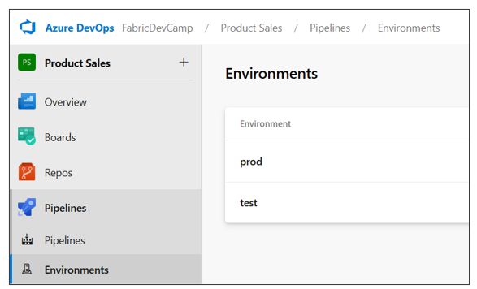
Once you have configured the two environments with a manual approval process, you can create Azure pipelines for a release process that target these environments. When you run an Azure pipeline targeting an environment with a manual approval process, the pipeline job pauses until the approval process completes. Once the approval is complete, the pipeline resumes and can use the fabric-cicd library to deploy the new release to a target workspace.
This guidance is intended to get you started developing Azure pipelines for Fabri CI/CD projects. As you begin to get up to speed on developing with Azure pipelines, you should become familiar with monitoring pipeline runs in order to test and debug your code. It's important to add logging to your code to report on successful operations and to provide diagnostic information about any errors that occur. The following screenshot shows how an Azure pipeline can log its progress in a Fabric CI/CD workflow.
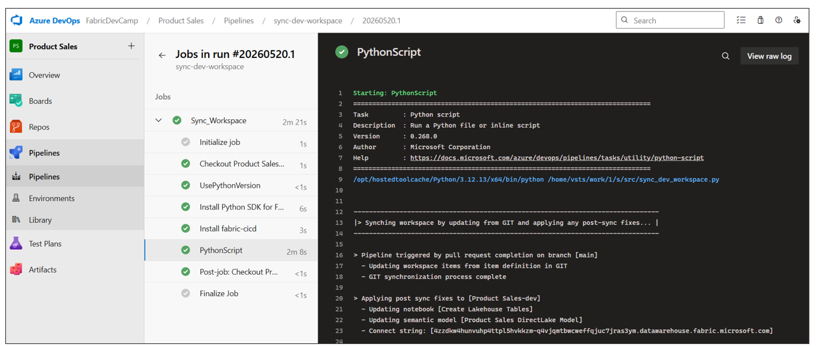
Azure DevOps Pipeline Resources
- Azure Pipelines documentation
- Key concepts
- YAML pipeline editor
- Manage variable groups
- Use Azure Key Vault secrets in Azure Pipelines

Developing GitHub Workflow Actions
GitHub is different from Azure DevOps with respect to how you work with projects and repositories. GitHub allows you to create repositories without first creating a project. While GitHub supports creating projects to assist with organizing repositories, the use of projects in GitHub is optional. When using GitHub for a Fabric CI/CD project, you just need to create a repository to get started.
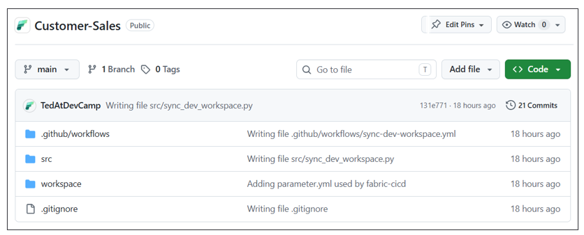
GitHub Actions is the platform in GitHub that allows you to develop workflows for CI/CD processes. You can create workflows using GitHub Actions that can be run on-demand or run on a schedule. You can also configure workflows to run in response to events such as a code commit or the completion of a pull request.
With GitHub Actions, you create a new workflow by copying a YAML file with workflow definition into a special repository folder named .github/workflows. Unlike Azure pipelines, there is no need to register the YAML file with GitHub. Just coping to YAML file into the .github/workflows folder is all you need to do for GitHub to recognize it as a Workflow Action. Inside the YAML file, it is possible to reference a script written in a language such as Python. The following screenshot shows a typical example of the file structure of workflow files for a Fabric CI/CD project in a GitHub repository.
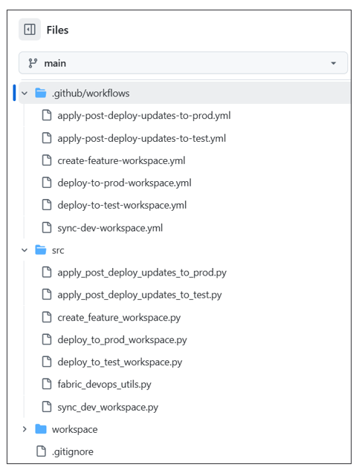
As you begin to develop GitHub Actions for a Fabric CI/CD project, you need a way to track environment settings such as the ids for workspaces, capacities, users and groups. Your code might also need authentication credentials to authenticate as a service principal. GitHub allows you to create secrets and variables to track these types of environment settings at two different levels. You can create secrets and variables at the scope of the repository or at the scope of a specific environment.
You can create secrets in GitHub at repository scope by navigating to Settings and selecting the Secrets and variables > Actions. When you create a secret, GitHub will encrypt its value and redact it from logs. A GitHub Actions workflow decrypts a secret at runtime, injects it into your workflow and then immediately discards it from memory when the workflow completes.
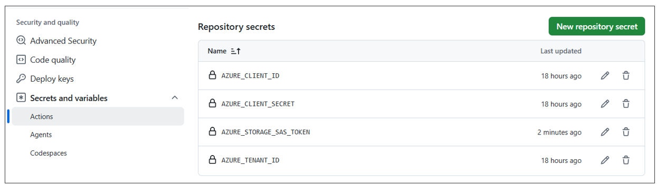
You can also add variables to a GitHub repository for environment settings that are not sensitive. The following screenshot shows an example of variables created for Azure pipelines in a Fabric CI/CD project.
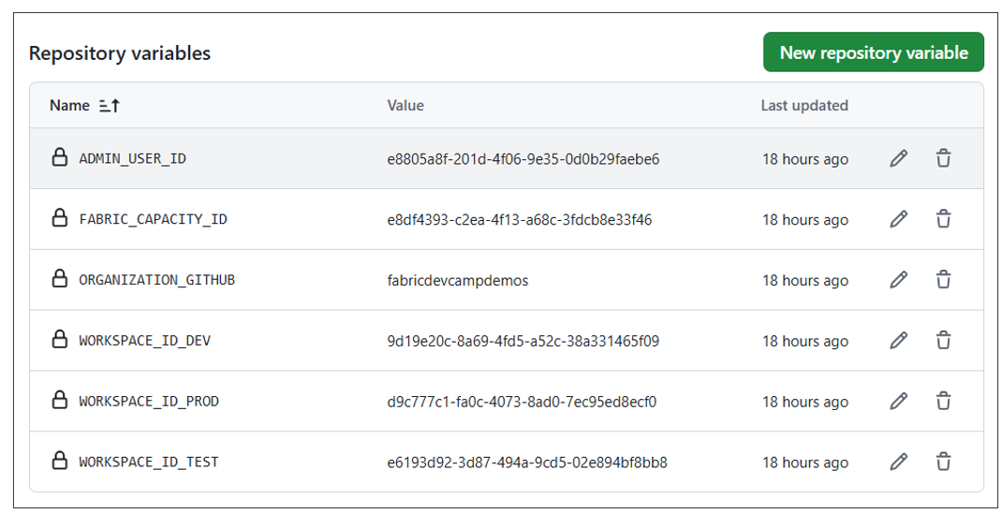
While creating secrets and variables at the repository level is adequate for some projects, you might find you need more granularity. GitHub supports a feature which allows you to create environments in a GitHub repository and then to create secrets and variables at environment scope.
Consider a CD release process in which workspaces don't exists within the same Entra Id tenant. For example, imagine the dev workspace, the test workspace and the prod workspace all exist in different Entra Id tenants. In this scenario, you will need different authentication credentials for each Entra Id tenant. You can start by creating three different environments in your GitHub repository named dev, test and prod.
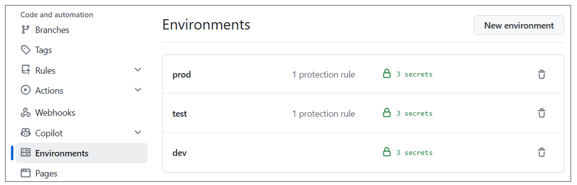
After that, you can configure each environment with the authentication credentials specific to its Entra Id tenant.
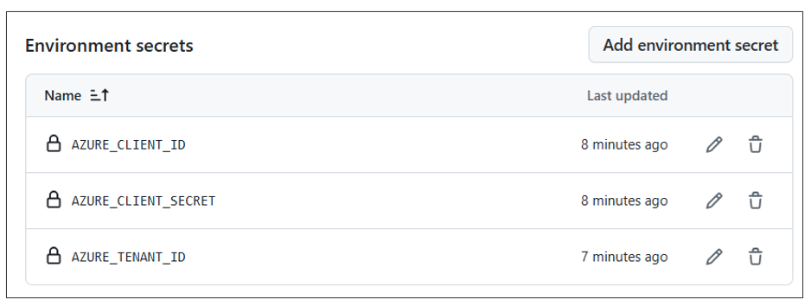
In addition to tracking environment-specific variables and secrets, an environment can be configured with protection rules. For example, you can create a protection rule for the test environment and the prod environment to require a manual approval process with one or more approvers. Once you have configured the two environments with a manual approval process, you can create GitHub Actions for a release process that target these environments. When you run a GitHub Action targeting an environment with a manual approval process, the GitHub Actions job pauses until the approval process completes. Once the approval is complete, the GitHub Actions job resumes and can use the fabric-cicd library to deploy the new release to a target workspace.
Once you have added the YAML file for a GitHub Actions into the .github/workflows folder, you can view those GitHub Actions in the left navigation of the Actions page. You can also select a workflow see its run history.
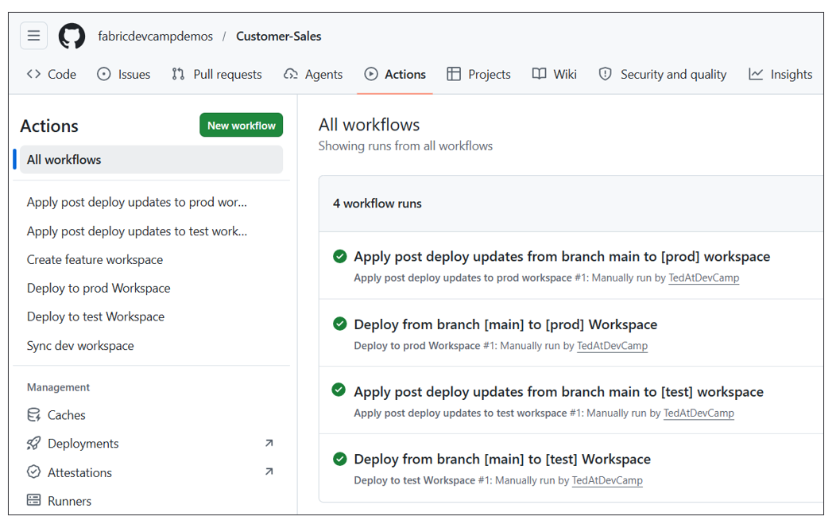
After selecting an action in the left navigation, you can drill into a specific workflow runs and view its logs. You can also run a action on demand by dropping down the Run workflow menu and clicking the Run workflow button. If you need to collect information from the user before running the workflow, you can define input fields in the workflow's YAML file. The following screenshot shows an example of a workflow with input parameters that prompt the user with a textbox and two checkboxes.
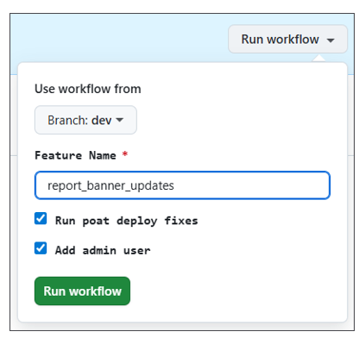
As you begin to develop workflows using GitHub Actions, you should become familiar with monitoring workflow runs in order to test and debug your code. It's important to add logging to your code to report on successful operations and to display diagnostic information about any errors that occur. The following screenshot shows an example of an GitHub Action written to log its progress in a Fabric CI/CD workflow.
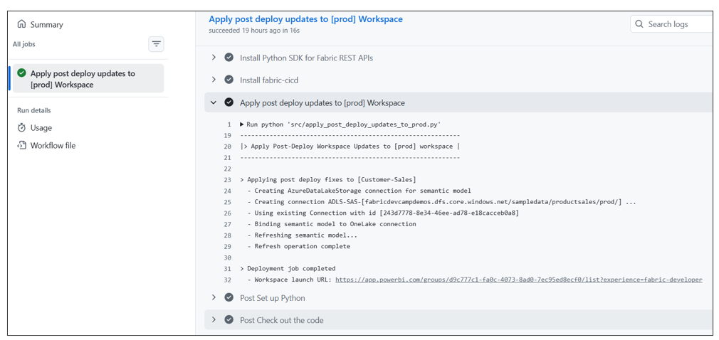
Resources for GitHub Actions Workflows
- Understanding GitHub Actions
- Workflows
- Variables
- Deployment environments

Summary
This guidance provided an overview of the Fabric platform's support for CI/CD. You learned that Fabric GIT integration and the ability to connect a workspace to a GIT branch provide the foundation for continuous integration and continuous deployment. Fabric GIT integration is based on serializing workspace items into item definitions which can be written to a GIT branch as a set of item definitions. Fabric is also able to initialize an empty workspace using a set of item definitions in GIT.
This overview introduced variable libraries which play an essential role in Fabric CI/CD. Variables libraries allow you to design a parameterization strategy by creating a set of variables and value sets. When used correctly, variable libraries help you to avoid writing code with hardcoded environment settings that change across environments and workspaces.
You learned there are several different approaches you can take for automation in a Fabric CI/CD project. You can leverage tools and libraries like Terraform, Fabric CLI and the fabric-cicd library. You also have the ability to call Fabric REST APIs directly if you feel the extra degree of control is worth the effort.
This guidance introduced the workflow development environments for Azure DevOps and GitHub. The development experience in Azure DevOps is based on Azure pipelines while development experience in the GitHub is based GitHub Action workflows. Both development environments provide a similar ability to create workflows using YAML-based files and to provide your code with access to variables and secrets. You should become comfortable with writing, testing and debugging code in one of these development environments if you are the one responsible for automation in a Fabric CI/CD project.

